**Goal Setting in the Eight Dimensions of Wellness**

**SAMHSA’s Eight Dimensions of Wellness are:**

1. Physical—Recognizing the need for physical activity, healthy foods, and sleep
2. Intellectual—Recognizing creative abilities and finding ways to expand knowledge and skills
3. Financial—Satisfaction with current and future financial situations
4. Environmental—Good health by occupying pleasant, stimulating environments that support well-being
5. Spiritual—Expanding a sense of purpose and meaning in life
6. Social—Developing a sense of connection, belonging, and a well-developed support system
7. Occupational—Personal satisfaction and enrichment from one’s work
8. Emotional—Coping effectively with life and creating satisfying relationships

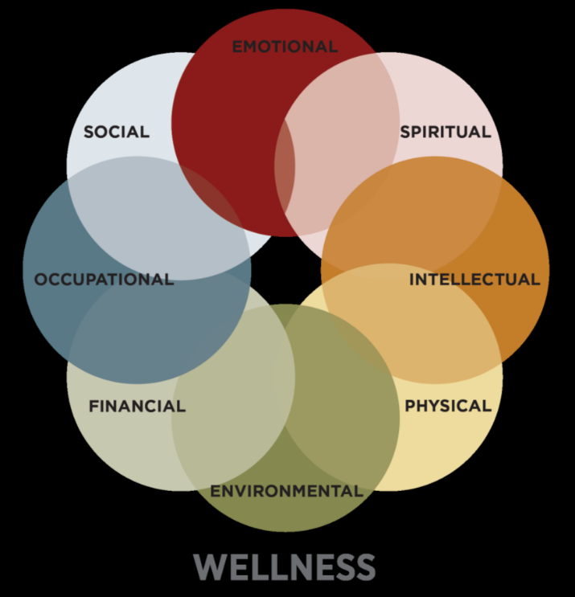

**Directions:** Read the description for each of the Eight Dimensions of Wellness presented by SAMHSA and then in the box provided, write in your goals to achieve your individual improved wellness for each of the eight dimensions. Remember that you can return on a regular basis to review the descriptions of the dimensions and then alter your goals to reflect your progress or lack of progress in achieving wellness in each of the specific dimensions.

1. **IMPROVING YOUR PHYSICAL WELLNESS**

A healthy body. Good physical health habits. Nutrition, exercise and appropriate health care. These make up the physical dimension of wellness. A few ways you can get there might be choosing things that make your body feel good and trimming back the things that bring you down. You can also feel better by creating a routine that balances activity with inactivity, and that is manageable within your obligations and needs. Your body is intelligent and learning to listen to it more deeply may be very important and empowering.

**Nutrition**

* Do you have access to fresh, healthy food?
* Are you in a position to eat at home so you can better track what you are putting into your body?
* Are you improving your diet by setting small goals for small changes each day, week, or month?

**Physical Activity**

* Are you getting regular physical activity whenever you can, and making it fun?
* Have you been taking “shortcuts” to exercise, like parking further away from the store and taking the stairs instead of the elevator or escalator?
* Have you identified your healthy Body Mass Index and begun working toward it, one day at a time?

**Sleep**

* Are you getting 7 to 8 hours of sleep a night whenever possible?
* Are you avoiding exercise within a few hours of bedtime, as well as “screen time”?
* Are you avoiding large meals before going to bed?

**Alcohol, Tobacco, and Other Drugs**

* Have you tried tools that can help you cut down or quit using tobacco products, alcohol, or other drugs?
* Are you reaching out to family or friends instead of using substances when you are going through a tough time?
* Are you being mindful of triggers that make you want to use substances and do you have a plan that can help you avoid them?

**Medication Safety**

* Do you wear medical alert jewelry to help others help you?
* Are you storing medications properly and reviewing the expiration dates?
* Do you carry a list of your medications with you in case of emergency?

**Preventive Medicine**

* Do you visit your doctor, dentist, or other health care provider for routine care and monitoring?
* Do you know how to check your blood pressure, waist circumference, and blood sugar to prevent chronic conditions like diabetes?

|  |
| --- |
| **My Goals for improving my Physical Wellness:** |

1. **IMPROVING YOUR INTELLECTUAL WELLNESS**

The Intellectual Wellness Dimension involves many things that keep your brain active and your intellect expanding. In a broad sense, this dimension can involve looking at different perspectives of an issue and taking them into consideration. Through a number of activities—from learning about current events to organizing game nights in your home or community center—you can broaden your perspective and understand diverse points of view.

**Personal Interests**

* Have you considered teaching a class or leading a workshop based on skills, knowledge, or experience you have?
* Do you enjoy reading? Might you be interested in books, magazines, blogs, Facebook, etc.?
* What would you like to do or learn? Have you considered creative arts such as drawing, pottery, or photography? How about martial arts or learning about nature or about improving your computer skills?
* Have you considered inviting a friend, family member, or coworker to attend a lecture, musical performance, or play?

**Education**

* If you are interested in continuing education, are there available classes near you that might lead you to getting a volunteer or paid job or to performing better at a job?
* Are you interested in improving your language skills or learning a new language, whether one-on-one, through a group class, or via CDs or online resources?

**Brain Exercise**

* Have you explored thrift shops, libraries, or bookstores for books or DVDs that interest you?
* Are you keeping your mind sharp by playing brain games, mind teasers, or fun memory-enhancing games?
* Have you read up on current affairs locally, nationally, and internationally lately?

**Conversation**

* Do you enjoy taking part in discussions, intellectual conversations, debates, or other ways of gaining an enhanced understanding of issues?

|  |
| --- |
| **My Goals for improving my Intellectual Wellness:** |

1. **IMPROVING YOUR FINANCIAL WELLNESS**

There are many definitions of what constitutes being financially well, but overall, the Financial Wellness Dimension involves things such as income, debt, and savings, as well as people’s understanding of financial processes and resources. People’s satisfaction with their current financial situation and future prospects also comes into play.

**Work**

* How does the domain of financial wellness impact your life? How it is related to your wellness?
* Does your current job allow you to meet your obligations and have resources to do things you enjoy?
* Are you working in a field that you are passionate about or do well? Or are you looking at doing something differently, perhaps more personally gratifying?
* Are you looking for paid or volunteer work?

**Checking/Savings Accounts**

* Do you balance your checkbook often enough, ensuring that you don’t overextend yourself?
* Are your savings in line with your life goals, such as taking a vacation, home ownership, or retirement?
* Do you have a weekly or monthly budget, so you can plan for expenses such as rent and groceries and have a little left over to enjoy?

**Debt**

* Would it be helpful to figure out your total debt and make a plan to pay it down in a manageable way?
* Have you thought about getting help from a person who specializes in money management or personal finances?

**Retirement/Other Accounts**

* Have you opened a savings account or another kind of account that works for you?
* However, if you’re receiving disability benefits, there’s a limit on how much you can save without affecting your benefits. SSI requires that your resources are under $2,000 for an individual or $3,000 for a couple. This includes bank accounts, cash, stocks, bonds. However, your home, household furnishings, car, burial plots, and insurance under $1,500 are not included.

|  |
| --- |
| **My Goals for improving my Financial Wellness:** |

1. **IMPROVING YOUR ENVIRONMENTAL WELLNESS**

The Environmental Wellness Dimension involves being able to be safe and feel safe. This can include:

* Accessing clean air, food, and water;
* Preserving the areas where you live, learn, and work;
* Occupying pleasant, stimulating environments that support your well-being; and
* Promoting learning, contemplation, and relaxation in natural places and spaces.

**Green Living**

* Are you recycling whenever possible, and buying recycled products?
* Do you limit the power and water you use at home?
* Are you taking public transportation?
* Do you check your car’s emissions every year, even if not required by law?

**Change of Scenery**

* Are you spending as much time outdoors as possible?
* Have you visited a public park to either play a sport like tennis or basketball or just take a walk?

**Home and Work Environment**

* Are you going through mail and other paperwork frequently to get rid of clutter?
* Do you organize your work space from time to time and add things that make you happy?
* Is your living space filled with styles and textures you enjoy?

|  |
| --- |
| **My Goals for improving my Environmental Wellness:** |

1. **IMPROVING YOUR SPIRITUAL WELLNESS**

The Spiritual Wellness Dimension is a broad concept that represents your personal beliefs and values and involves having meaning, purpose, and a sense of balance and peace. It includes:

* Recognizing your search for meaning and purpose in human existence; and
* Developing an appreciation for life and the natural forces that exist in the universe.

**Beliefs**

* Are you taking the time to determine what values, principles, and beliefs are important to you? Have you considered talking about them with others?
* Have you learned about other religions and beliefs, and are you respectful of them?
* Are you using your spirituality to drive your actions and thoughts and give a better meaning to life?

**Involvement**

* Have you looked for a group in your community that deepens your spiritual practice and helps you connect with others who share your beliefs?
* Are you being social with the people in your organization?
* Do you reach out and help others when they are in need?

**Time**

* Do you take the time each day to meditate or reflect on your spirituality?
* Are you open to exploring different belief systems?
* Are you receptive to your own spirituality even in times of pain and grief? This is when you find how your spirituality can help you most.
* Do you take the time to appreciate the beauty of nature when possible?

|  |
| --- |
| **My Goals for improving my Spiritual Wellness:** |

1. **IMPROVING YOUR SOCIAL WELLNESS**

The Social Wellness Dimension involves having healthy relationships with friends, family, and the community, and having an interest in and concern for the needs of others and humankind.

**Community**

* Have you found support groups in your area to connect on important issues?
* Have you made a date with friends for a movie, dinner, coffee, or other social activities?
* Are you keeping in touch with family or friends? You can pick up the phone and catch up if they are too far away—even a phone call can lift your spirits.

**New People**

* Are you getting out and meeting people with your same interests? If you like art, try a gallery; if you enjoy history, visit historic sites.
* Are you open to meeting people from different backgrounds?
* Have you found a place to volunteer? You never know who you might meet.

**Social Time**

* Do you set aside quality time to spend with family and friends?
* Are you making time to go to places where you can meet new people, or visiting a new location?

|  |
| --- |
| **My Goals for improving my Social Wellness:** |

1. **IMPROVING YOUR OCCUPATIONAL WELLNESS**

The Occupational Wellness Dimension involves participating in activities that provide meaning and purpose and reflect personal values, interests, and beliefs, including employment

**Work Relationships**

* Are you involved in a career or volunteer work that fits your values? If retired, are you planning to do something every day?
* Do you have an open line of communication with your employer/coworkers?
* Does your work offer personal satisfaction and stimulation, and allow you to contribute your talents, gifts, and knowledge?

**Balance**

* Do you schedule time for leisure? Are you spending time with friends, taking nature walks, scheduling massages, or doing whatever it takes to relax?
* Are you thinking about how you spend time each day and considering volunteer work in the community?

**Accomplishment**

* Are you in a career that you look forward to and that gives you a sense of accomplishment and pride?
* Are you patting yourself on the back for your accomplishments?

|  |
| --- |
| **My Goals for improving my Occupational Wellness:** |

1. **IMPROVING YOUR EMOTIONAL WELLNESS**

The Emotional Wellness Dimension involves the ability to express feelings, adjust to emotional challenges, cope with life’s stressors, and enjoy life. It includes knowing your strengths as well as what you want to get better at, while living and working on your own but letting others help you from time to time.

**Feeling/Emotions**

* Do you allow yourself to be open to and acknowledge your feelings without judgment?
* Have you found and developed safe relationships with people or groups where you can express your feelings and thoughts?
* Do you see challenges as opportunities for growth?
* Do you recognize your limitations and learn from your mistakes?
* Are you taking responsibility for your actions?

**Self-Care**

* Have you joined support groups, or thought about starting one?
* Do you write your thoughts in a journal, listen to music, or talk to family or friends when you are in need?
* Have you tried yoga, breathing, or meditation to remain calm and centered?
* Are you maintaining a daily routine?
* Do you leave yourself plenty of time to get to work and other obligations?
* Are you eating some meals without distractions, like checking your phone or watching TV?

**Stress**

* Are you learning to manage stress in ways that work for your lifestyle?
* Do you recognize stress triggers and appreciate that you are not your feelings? Feelings are fleeting and will pass.
* Do you welcome and cultivate positive, empowering thoughts and emotions?

|  |
| --- |
| **My Goals for improving my Emotional Wellness:** |