**Goal Setting for Your Whole Health**

The VA promotes the Components of Proactive Health and Well-Being with the picture below which will help you think about your whole health. All of the areas in the circle are important. They are all connected. Improving one area can benefit other areas in your life and influence your overall physical, emotional, and mental health and well-being. The human body and mind have tremendous healing abilities and you can strengthen these healing abilities. The inner circle represents you, your values and what really matters to you. Being in a state of mindful awareness helps you see what matters to you. The next circle is your self-care. These are the circumstances and choices you make in your everyday life. The next ring represents professional care you receive. Professional care may include tests, medications, supplements, surgeries, examinations, treatments, and counseling. This also includes complementary approaches such as acupuncture and mind-body therapies. The outer ring represents the people and groups to whom you are connected.

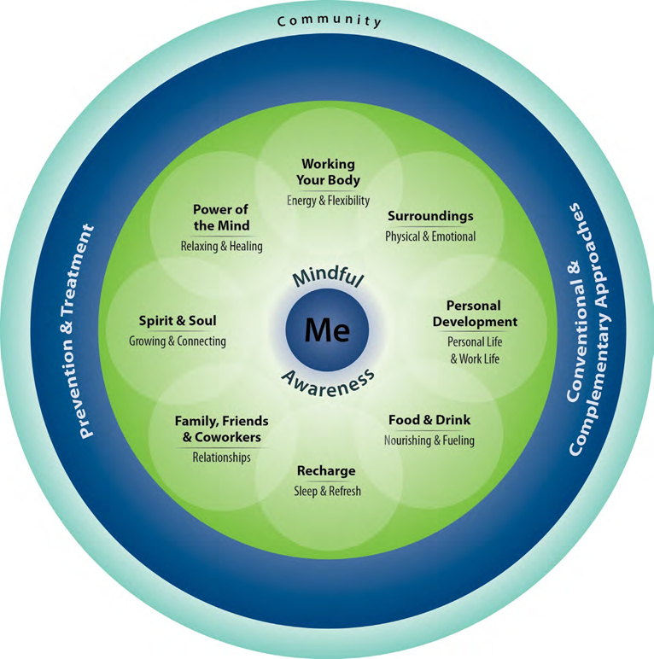

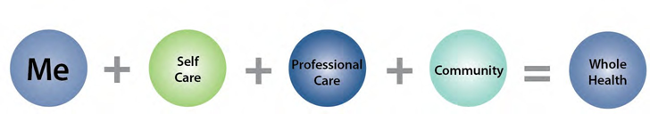

**THE EIGHT AREAS OF SELF CARE**

Self-care is often the most important factor in living a healthy life, which in turn allows you to live your life fully, in the ways that matter to you. Self-care includes all the choices you make on a daily basis that affect your physical, mental, and spiritual health. In fact, how you take care of yourself will have a greater impact on your health and well-being than the medical care you receive. Evidence shows that each of these eight areas of self-care contributes a great deal to your overall health and well-being. They can also affect your chances for developing diseases as well as the seriousness of that disease. Consider your values, lifestyle, habits, and motivations in each area. Taking stock of where you are now and where you want to be in each of these areas is the first step in living a healthier life.

**Directions:** Read each of the 8 Areas of Self-Care and then put in your goal to improve each of these areas in your life.

1. **Working Your Body “Energy and Flexibility”**

“Energy and Flexibility” includes movement and physical activities like walking, dancing, gardening, sports, lifting weights, yoga, cycling, swimming, and working out in a gym. Exercise gives you energy and strength. Movement can make you more flexible. Exercise is also good for your mind. Regular exercise can lower blood pressure and cholesterol and reduce the risk for heart disease. Examples of exercise and movement include walking, gardening, dancing, or lifting weights. It’s important to find what works for you.

|  |
| --- |
| **My Goals for improving my Working my Body:** |

1. **Surroundings “Physical and Emotional”**

“Physical and Emotional” means feeling safe by having comfortable, healthy spaces where you work and live which includes: the quality of the lighting, color, air, and water and decreasing unpleasant clutter, noises, and smells. Your environment can affect your health. You may have problems with safety, or things like clutter, noise, bad smells, poor lighting or water quality. You may be able to change some of these problems. You may not be able to change them all. It starts with paying attention to the influences of your environment on your life and health. Improve what you can. It’s good to have a safe, comfortable, and healthy space.

|  |
| --- |
| **My Goals for my improving my Surroundings:** |

1. **Personal Development “Personal Life and Work Life”**

“Personal life and Work life” means learning and growing, developing abilities and talents while balancing responsibilities where you live, volunteer, and work. No matter where you are in life, your personal and work life is very important. How do you spend your time and energy during the day? Do things give you energy or make you tired? Do you spend time doing what matters most to you? How do you feel about your finances and how are they affecting your life? These factors affect not only your happiness, but also your health.

|  |
| --- |
| **My Goals for my improving my Personal Development:** |

1. **Food and Drink “Nourishing and Fueling”**

“Nourish and Fuel” means eating healthy, balanced meals with plenty of fruits and vegetables each day and drinking enough water and limiting sodas, sweetened drinks, and alcohol. What you eat and drink can nourish your body and mind. Choose healthy eating habits that fit your lifestyle. Certain supplements can support your health goals. Limit alcohol, caffeine, and nicotine. Keep your body and mind properly fueled.

|  |
| --- |
| **My Goals for my improving my intake of Food and Drink:** |

1. **Recharge “Sleep and Refresh”**

“Sleep and Refresh” means getting enough rest, relaxation, and sleep. Sleep is very important for your body and mind. Rest can give you peace. Relaxation can lower stress. Activities you enjoy can help you feel recharged. A good balance between activity and rest improves your health and

well-being.

|  |
| --- |
| **My Goals for my improving my Recharge:** |

1. **Family, Friends, and Co-Workers “Relationships”**

“Relationships” means listen to feelings of others and connect to people you love and care about which improves the quality of your communication with family, friends and people you work with. Feeling alone can sometimes make you get sick or keep you sick. Positive social relationships are healthy. A healthy intimate relationship with a life partner can be a source of strength. It’s good to talk to people who care about you and listen to you.

|  |
| --- |
| **My Goals for my improving my Relationships with Family, Friends & Co-Workers:** |

1. **Spirit and Soul “Growing and Connecting”**

“Growing and Connecting” is having a sense of purpose and meaning in your life and feeling connected to something larger than yourself which helps you find strength in difficult times. A sense of meaning and purpose in life is important to many people. When things are hard, where do you turn for strength and comfort? Some people turn to spiritual or religious faith. Some people find comfort in nature. Some connect with art, music or prefer quiet time alone. Some want to help others. You may express this as a guide to living fully.

|  |
| --- |
| **My Goals for my improving my Spirit and Soul:** |

1. **Power of the Mind “Strengthen and Listen”**

“Strengthen and Listen” is tapping into the power of your mind to heal and cope by using mind-body techniques like relaxation, breathing, or guided imagery. Your mind can affect your body. Sometimes when you think about stressful things, your heart rate and blood pressure go up. You can use the power of your mind to lower blood pressure or control pain. Learn to use the connection between your body, brain, and mind. Warriors and athletes use the power of the mind to visualize a successful mission or event. Mind-body practices tap into the power of the mind to heal and cope.

|  |
| --- |
| **My Goals for my improving the Power of my Mind:** |

**PROFESSIONAL CARE**

Prevention and treatment of illness or disease and traditional and complementary medicine are part of professional care. Preventive care includes things like immunizations and cancer screening. Common treatments include check-ups, medicines, supplements, physical therapy, surgery, and counseling. Complementary medicine includes approaches like acupuncture and mind-body therapies. It is important to stay current with your personal care plan for health and well-being.

**COMMUNITY**

The outer ring represents your community. For some, their community is close and for others it is far away. Your community is more than the places where you live, work, and worship. It includes all the people and groups you connect with; who rely on you and upon whom you rely.