**Dealing with the Opioid Crisis**

**Opioid-Heroin Epidemic Defined**

**CDC's official definition of an epidemic is:**

"The occurrence of more cases of disease than expected in a given area or among a specific group of people over a particular period of time.”

* Since 1999 the rate of overdose deaths involving opioids including both prescription pain medication and heroin nearly quadrupled
* Heroin use has increased across the US among men and women, most age groups, and all income levels

**Factors Driving the Epidemic**

* Wider availability of prescription opioids
* 1999-2013 the amount of prescription opioids dispensed in the US nearly quadrupled
* Increasing non-medical use and overdose
* Changing economics and supply of heroin
* Cheaper, available, higher purity, synthetics
* Increasing heroin use and overdose
* Lack of access to treatment
* 80% with SUD are not in treatment

**Prevalence of Pain and Substance Use Disorders (SUD)**

* 100 million Americans have persistent pain- IOM study, 2011
* Pain costs society at least $560‐$635 billion annually - IOM study, 2011
* $261‐$300 billion in health care costs
* $297‐$336 billion in lost productivity
* In 2013, 1.9 million people had a substance use disorder

**Prescribed Opioid Abuse**

* Over 16,000 died of an opioid‐related overdose - SAMHSA, 2014
* 4.3 million nonmedical users of Prescribed opioids age 12 or older - SAMHSA, 2014
* 467,000 adolescents were current nonmedical users of prescribed opioids, with 168,000 having an addiction to them - SAMHSA, 2014

**On an average day:**

* 650,000 opioid prescriptions dispensed
* 3,900 people initiate nonmedical use of prescription opioids
* 580 people initiate heroin use
* 91 people die from an opioid related overdose

**Re-emergence of Fentanyl**

* Schedule II synthetic opioid analgesic
* Up to 50-100x more potent than morphine and 30-50x than heroin
* Mixed with adulterants and sold as “synthetic heroin”
* 2015 death rate from synthetic opioids increased 72.2%
* Comes from several sources
* Diverted from legal medical use
* Clandestine – manufactured in Mexico or China

**Risk groups for Heroin Addiction**

* People who are addicted to prescription opioid painkillers are at most risk for addiction to heroin
* People who are addicted to cocaine
* People without insurance or enrolled in Medicaid
* Non-Hispanic whites
* Males
* People living in large metropolitan areas, particularly in the Northeast and Midwest

**The relationship between Heroin & Prescription Opioids**

* Both prescription opioids and heroin are chemically related and just as addictive
* Act on nerve cells in the brain and nervous system the same way – pleasurable effects and relieve pain
* People who are addicted to prescription opioid painkillers are at high risk for addiction to heroin 19x more likely to use
* Injecting drug use (IDU) increases the risk of serious, long-term viral infections such as HIV, Hepatitis B and C
* 11% of new HIV infections are from Injecting Drug Use (IDU)
* 50% of new Hepatitis C infections are from Injecting Drug Use (IDU)
* 114% increase in Emergency Room and Doctor visits
* Neo-natal abstinence syndrome
* Increase in fractures in older adults due to falls
* Significant co-occurring Myocardial Infarction (health attacks) with SUD
* Use of these both result in anxiety, mood disorders or depression

**Heroin Use**

* 517,000 had a heroin use disorder, compared with 189,000 in 2002-SAMHSA, 2014
* Between 2002 and 2013, the rate of heroin‐related overdose deaths nearly quadrupled. Over 8,200 died in 2013 - CDC
* People who abuse prescribed opioids rarely use heroin, and the transition to heroin use appears to occur at a low rate - NIDA 2016
* Researchers suggest that the major drivers of the recent heroin use increases and related deaths are:
* Increased accessibility
* Lower market price
* High purity

**Heroin Types**

**A. Heroin Pills**

* Counterfeit oxycodone containing heroin in KY & OH
* Indistinguishable from legitimate pills; identified through lab tests

**B. Heroin laced with fentanyl**

* 40 times as strong as pure heroin
* 700 heroin-fentanyl‐related deaths from late 2013 through 2014
* 74 people overdosed in 3 days in Chicago

**C. “China White” – heroin laced with acetyl fentanyl-analog**

* Deaths jumped 500% - 43 in ME between 2013 and 2014
* 600% increase in deaths - 49 in Cabarrus County, NC

**D. Hollywood – “exceptionally” lethal form of heroin**

* 8 people overdosed in 1 week in Western Massachusetts

**The Hepatitis C/HIV Infection Epidemic**

* 150% increase in new infections 2010-2013
* Almost 50% of new cases associated with injection drug use
* Occurring in young people (<30), in rural and suburban areas
* Use of oral prescription opioids before transitioning to injecting

**Hepatitis C and HIV transmissions**

* Outbreak in southeastern Indiana community of 4,200: 170 with HIV and 122 with hepatitis C- 06/2015
* Miami‐Dade and Broward County are the top two counties in the U.S. for new HIV cases; transmissions presumed to be associated w/ opioid abuse/heroin use - 09/2015

**Partial Progress**

Decrease in prescription drug abuse‐related deaths

* CDC: 3% nationwide in 2012
* SAMHSA: 14% among adults ages 18 to 25 nationwide in 2011

Decrease in prescription opioid‐related deaths

* CDC: 5% nationwide in 2012 - 1st time in over a decade
* 27% in FL between 2010 and 2012
* 29% in Staten Island between 2011 to 2013

**Making this Epidemic More Personal – What’s Happening in Our Own Back Yard?**

**Pinellas County:** number of fatal overdoses in Pinellas jumped at least 53 percent from 2015 to 2016. There were 274 confirmed overdoses and, with seven cases still pending, the final tally could eclipse the 280 deaths in 2010 when oxycodone abuse was rampant.

**Pasco County:** had a 34 percent increase in drug deaths in 2016.

**Hillsborough County**: has not yet tallied its numbers but expects an increase.

* This problem is being driven by a combination of heroin and fentanyl. The potency is higher and the cost cheaper, and so the results are tragically familiar.
* The Florida Department of Law Enforcement reported heroin deaths in Florida were up about 75 percent, and fentanyl deaths were up 70 percent from 2014 to 2015.

**WE ALL NEED TO WORK TOGETHER**

There is a need to work with all aspects of our society to address this crisis:

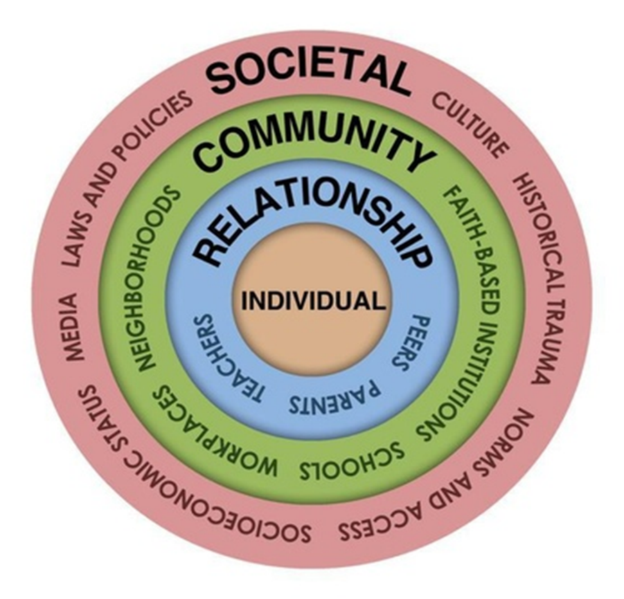

**We are all part of the solution!**

**1. Prevention**

* Educating the public on the risk of prescription opioid use
* Tolerance, addiction, overdose, death
* Educating healthcare providers on safe prescribing/treatment of pain
* Guidelines such as the: Opioid Overdose Prevention TOOLKIT
* Non-opioid chronic pain management such as: Managing Chronic Pain in Adults With or in Recovery From Substance Use Disorders
* Reduce stigma associated with addiction
* Language
* Use of medications to treat addiction (MAT)
* Treatment of chronic illness

**2. Early Intervention**

* Screening/Identification - All ages, multiple settings
* Brief interventions - Short conversation to provide feedback and advice
* Referral to treatment with a warm handoff
* Overdose prevention, use of naloxone (narcan): Opioid Overdose Prevention TOOLKIT
* Syringe service programs using guidelines such as: HIV and Injection Drug Use Syringe Services Programs for HIV Prevention

**3. Treatment**

**Long term**

* Detox is a first step
* Medications
* Methadone
* Buprenorphine
* Naltrexone

**Psychosocial Interventions**

* CBT (relapse prevention, 12 step facilitation, social skills)
* Individual, group, family counseling

**Recovery Supports**

* 12 Step Programs
* Peers support groups

**4. Recovery**

**An Integrated Approach**

* Focusing on the Whole Person
* Integrating behavioral health into the HIV care continuum
* Integrating behavioral health into the primary care system
* Integrating behavioral health into the education/school systems

**Community Partnerships - Goal: Every door is the right door**

* SUD Treatment Programs and Emergency Rooms
* Public health and behavioral health programs
* Primary care and SUD treatment programs
* Schools and prevention coalitions
* Entitlement programs (Medicaid) and SUD treatment programs
* HHS training and Technical Assistance center collaborative

**Prevention Strategies**

**The people** who are over-using prescription pain killers (opioids) can do

Talk with their doctors about:

* The risks of prescription painkillers and other holistic ways to manage their pain
* Making a plan on when and how to stop, if a choice is made to use prescription painkillers
* Use prescription opioids only as instructed by their doctors
* Store prescription painkillers in a safe place and out of reach of others
* Never use another person's prescription opioids

**The prescribers**

* Talk with their patients about the risks of taking prescription opioids, including addiction/tolerance, overdose and death
* Prescribe the lowest effective dose, only the quantity needed for the expected duration of pain and/or discuss other options to manage pain
* Follow best practices for responsible opioid prescribing
* CDC guidelines for chronic pain
* American Society for Addictive Medications (ASAM) guidelines
* Use their state’s Prescription Drug Monitoring Program (PDMP) to identify patients who might be misusing prescription drugs and are at risk of overdose
* Become trained to provide medications for addiction

**Healthcare/Treatment Providers**

* Treat the whole person – integrated approach
* Address health beliefs, wellness, health literacy
* Regularly screen for depression and use of substances
* Talk with their patients about the risks of using opioids
* Identify and reach out to potential partners in their communities, provide information on their services

**All of us**

* Learn more about the risks of using heroin and other drugs
* Learn how to recognize and respond to an opioid overdose (SAMHSA Overdose Tool Kit-See Below)
* Know how to access treatment resources in your community
* Behavioral Health Agency, Mental Health/Substance Abuse Treatment Agencies,
* Be aware of what policies and practices that the State is implementing
* Stay updated!

**Pain: The Root of the Problem**

**What is Chronic Pain?**

* Chronic Pain Syndrome (ICD-10 CM G89.4)
* Pain for at least 3 months AND:
* Extreme focus on and/or amplification of pain
* Major inactivity and/or deconditioning
* Disrupted sleep
* Multiple work ups and/or failed treatments
* Depression and irritability
* Significant reduction in social activities

**Prevalence of Chronic Pain**

50 million American adults with chronic pain

25 million had daily chronic pain

23 million more reported severe pain (affecting their activities of daily living- ADLs)

**Pain Conditions**

* Low back pain 35%
* Migraine 7.5%
* Fibromyalgia 7%
* Lumbar radiculopathy 4.5%
* Cervical radiculopathy 3.5%
* Neuropathy 5%
* Other neurologic condition 5%

**Biopsychosocial Model of Pain**

Pain is a subjective experience

* It is a physical sensation, but it is an unpleasant and therefore emotional experience
* Pain impacts and is impacted by various factors
* Necessary to address all to impact the development, maintenance, and impact of chronic pain

**Psychological Factors and Pain**

* A mild degree of depression, anxiety, and irritability is abnormal psychological response to pain
* 30-40% of those with chronic pain in Primary Care fall into the subgroup with significant psychiatric comorbidity
* 50-75% in pain specialty settings with major depression or anxiety disorder

**Opioids Prescribed in the USA**

* Avinza - morphine sulfate ER capsules
* Butrans - buprenorphine transdermal system
* Dolophine - methadone hydrochloride tablets
* Duragesic - fentanyl transdermal system
* Embeda - morphine sulfate/naltrexone ER capsules
* Exalgo - hydromorphone hydrochloride ER tablets
* Hysingla - ER (hydrocodone bitartrate) ER tablets
* Kadian - morphine sulfate ER capsules
* Methadose - methadone hydrochloride tablets
* MS Contin - morphine sulfate CR tablets
* Nucynta - ER tapentadol ER tablets
* Opana - ER oxymorphone hydrochloride ER tablets
* OxyContin - oxycodone hydrochloride CR tablets
* Targiniq - oxycodone hydrochloride/naloxone hydrochloride ER tablets
* Zohydro - hydrocodone bitartrate ER capsules

**Generic Products**

* Fentanyl ER transdermal systems
* Methadone hydrochloride tablets
* Methadone hydrochloride oral concentrate
* Methadone hydrochloride oral solution
* Morphine sulfate ER tablets
* Morphine sulfate ER capsules
* Oxycodone hydrochloride ER tablets

**Medications for the treatment of opioid addiction and overdose**

* Methadone – Full Agonist (See Note below) of Opioids
* Buprenorphine(bupe) - Partial Agonist of Opioids - suboxone, subutex, zubsolv, bunavail
* Extended release Naltrexone (XRNTX) – Antagonist of Opioids - Vivitrol

**For Overdoses**

* Naloxone – Narcan

**NOTE:** An agonist is a chemical that binds to a receptor and activates the receptor to produce a biological response. Whereas an agonist causes an action, an antagonist blocks the action of the agonist and an inverse agonist causes an action opposite to that of the agonist.

**Effectiveness of medications for opioid addiction**

**Methadone**

* Multiple clinical trials and meta-analyses (e.g. Cochrane)
* Below 50% have 6-month abstinence retention

**Buprenorphine**

* Multiple clinical trials and meta-analyses (e.g.Cochrane)
* 50% have 6-month abstinence retention

**Naltrexone-Vivitrol**

* Limited effectiveness in pill form
* Long acting injections and implants produce around 50% retention and sustained abstinence (e.g. Krupitsky et al., 2011)

**Choice of medication: Methadone vs Buprenophine vs XR-NTX (extended release naltrexone)**

* Patient preference and family preference
* Failure of other treatments, try something new
* Side effects, anxious anticipation
* Long acting duration of XRNTX
* Methadone and bupe intrinsically reinforcing
* Methadone and bupe relieve withdrawal early
* All 3 relieve cravings
* More familiarity with methadone and bupe, positive and negative reputation
* Partial blockade for bupe, full blockade for XRNTX
* Strong opioid effects for methadone, pros and cons
* Problems with acceptability of agonists
* More tools in the toolbox

**How to Train Participants in an Opioid Overdose Prevention Program before prescribing Naloxone Rescue Kits:**

* Have you ever had an accidental overdose?
* What were the circumstances, what happened, how did you survive?
* Have you ever witnessed an overdose? What did you do?
* What do you do to protect yourself from overdose?
* What are some risk factors for overdose?
* Have you heard about naloxone/Narcan for reversal of overdose?

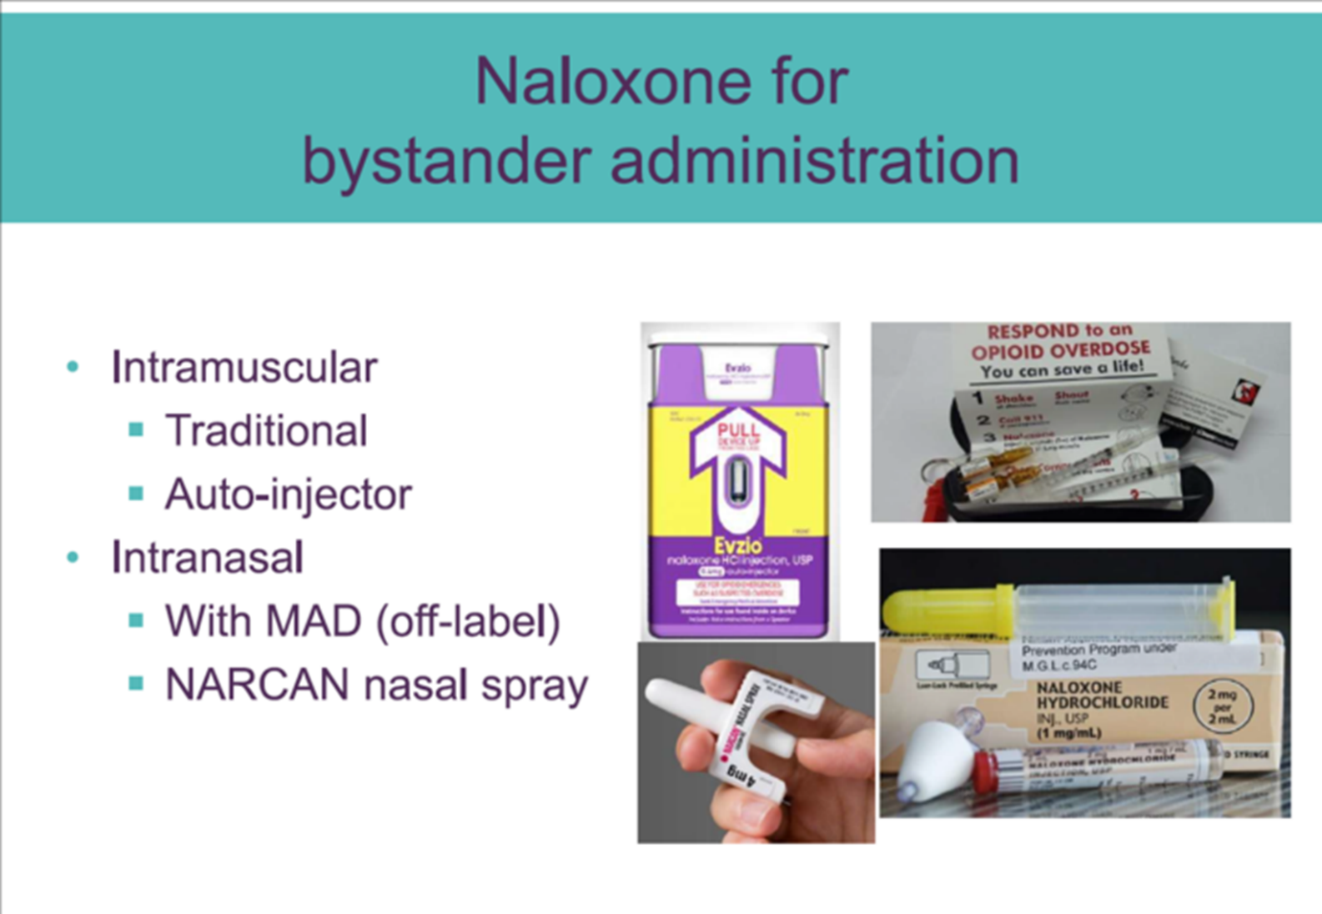

**What is in a Rescue Kit?**

* Two doses of naloxone or devices
* Two syringes or mucosal atomizing devices (MAD)
* Instructions on use

May also include:

* Alcohol swabs
* Face shields
* Gloves