Pinellas Hope Independent Living Skills
ANGER Workout
The typical unhealthy anger cycle
- When you express anger in your old "sick'' way, the automatic natural response is guilt for hurting the feelings of the person
- You immediately feel remorse.
- You then suppress the anger. However, you still feel resentment over the real or perceived stimulus which prompted your anger.
- If you are again irritated by this or a similar stimulus, you will express anger again.
- It is not useful in your recovery process to express your anger directly on people in the old "sick'' way which keeps you trapped in the anger cycle
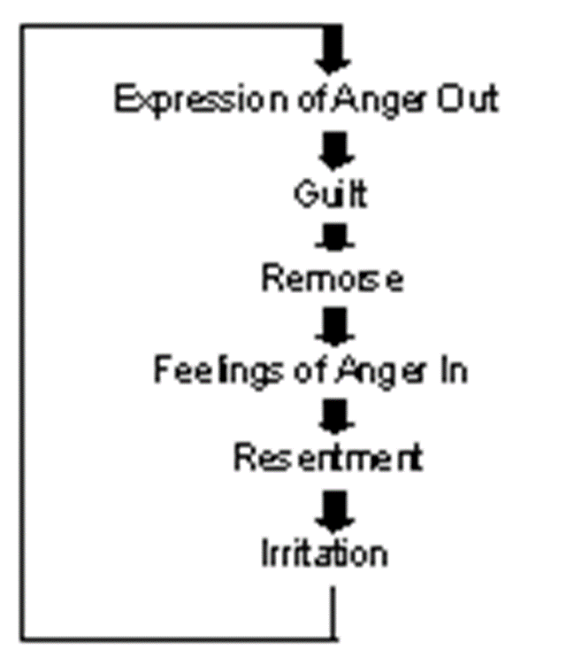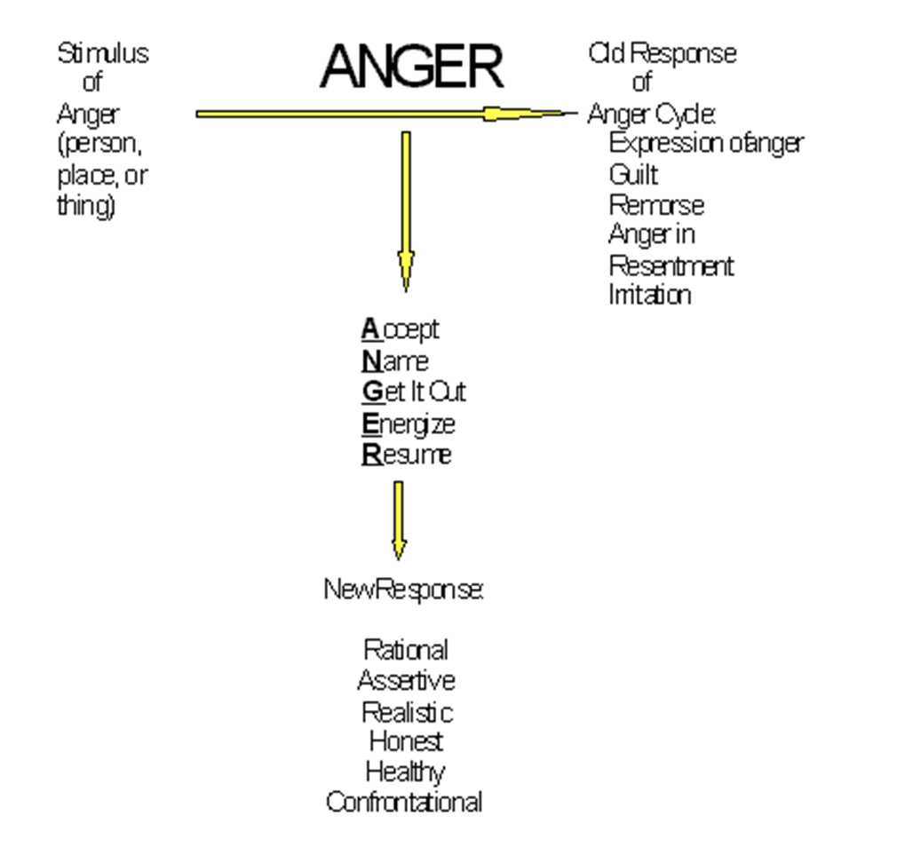
A - Accept
First, you need to accept that what you are feeling is anger. There is often a tendency to deny this powerful emotion because your experience with anger in the past has been painful, hurtful, or disastrous. Don't deny your anger. Face it head on for what it is.
N - Name
Second, you need to name and identify what is getting you so angry. You need to name what it is about the stimulus which is triggering your response. Utilize the TEA and ALERT systems to help you to analyze and think out what is going on to get you angry. You need to identify not only the current anger but also the old unresolved anger that the stimulus may be provoking.
G - Get It Out
Third, you now need to get it out of your system by expressive emotional release of anger workout. Get yourself in a private place (if you can) to use one of the following activities to aggressively ventilate you anger on inanimate objects rather than on people:

Yelling in your head silently
Yelling in a car with windows closed
Yelling in a room away from others
Yelling into a paper bag or pillow
Beating on pillows, cushions, or mattress
Hitting a punching bag, weight bag
Screaming in a vacant field or lot
Screaming with a towel in your mouth
Ripping a telephone book, newspaper, or catalogue

E - Energize
Fourth, once you have aggressively ventilated and experienced emotional release of the anger, you will energize yourself to feel calmer, more relaxed, less anxious, less tense, or less stressed. Aggressive anger work will enable you to be more rational and realistic and better able to use the TEA and ALERT systems to promote your recovery.
R - Resume
Fifth, once you are energized, resume your involvement with the person who was the stimulus of the anger and assertively confront the person with how you feel in a calm, cool, rational manner.
Being Assertive in a Healthy Way

Assertive behavior is:
- Standing up for one's rights no matter what the circumstance.
- Correcting the situation when one's rights are being violated.
- Seeking respect and understanding for one's feelings about a particular situation or circumstance.
- Interacting in a mature manner with those found to be offensive, defensive, aggressive, hostile, blaming, attacking, or otherwise unreceptive.
- Direct, upfront, (not defensive or manipulative) behavior. Those using assertive behavior confront problems, disagreement, or personal discomforts head on, and their intent is unmistakable to others.
- Verbal “I” statements, where individuals tell others how they feel about a situation, circumstance, or the behavior of others.
- Taking the risk of being misunderstood as being aggressive, abrasive, or attacking.
- Being able to protect one's rights while protecting and respecting the rights of others.
- Risk-taking behavior that is not ruled by fear of rejection or disapproval, but is directed by the rational belief that I deserve to stand up for my rights.
- Rational thinking and the self-affirmation of personal worth, respect, and rights.
- A healthy style in which to conduct interpersonal relationships.
- Finding a win-win solution in handling problems between two individuals.

How to conduct a direct, assertive, angry confrontation:
When someone or something gets me angry, I need to:
Step 1: Identify exactly what gets me angry. What do I feel is a violation of my rights? Which rights have been violated? Example: I'm ignored by the leader of our group, and this affects my right to be heard.
Step 2: Identify the behavior that is so upsetting. Why do I feel the way I do? Example: The leader acts all knowing.
Step 3: Tell the person directly how the behavior makes me feel by using an “I” statement, like: When you did (the behavior) it made me angry (or other feeling.) Example: When you ignored my input last night and you were acting like a know-it-all I was angry, hurt, and upset.
Step 4: Once I've given my “I” statement, I can describe corrective action, like: In the future when you feel like (describe person's feelings) then you have my permission to take the following action: (describe it.) I think that's fair. Example: In the future if you feel my input is irrelevant, you have permission to tell me and ask me to explain myself.
Step 5: Once I've secured corrective action for the confrontation, I give the person permission to call me on it if I continue to dwell on this episode anytime I get angry in the future. Example: If I bring up this episode again, please remind me of our agreement.
Step 6: Finally, I do healthy anger work-out through journal writing, until I have exhausted my anger over this episode and those involved. This is done in private.
Handling Self-Destructive Angry Responses
Self-Destructive Self-Inventory
I will rate each self-destructive response by checking the degree to which it is true for me using this scale: 1 = never; 2 = rarely; 3 = sometimes; 4 = often; 5 = almost always
- 1. overuse of alcohol
- 2. overuse of nonprescription drugs
- 3. overuse of prescription drugs
- 4. shoplifting
- 5. petty theft from my employer
- 6. illegal acts of revenge on my enemies
- 7. compulsive gambling
- 8. compulsive overeating or binging
- 9. binging and purging
- 10. anorexia
- 11. compulsive exercising
- 12. compulsive shopping
- 13. overuse of credit cards
- 14. compulsive drive to acquire material goods
- 15. putting myself down in public
- 16. setting myself up for failure
- 17. unwillingness to play the political survival game on the job
- 18. ignoring authority directives
- 19. direct disobedience of authority directives
- 20. insubordination on the job
- 21. arriving late to work or school
- 22. excessive absenteeism
- 23. playing hookey or skipping required work and/or functions
- 24. ignoring personal hygiene
- 25. dressing in such a way as to hide my beauty or sexuality
- 26. jumping to negative assumptions about motives when people show an interest in me
- 27. feeling like a loser even when I wasn't
- 28. ignoring the yes messages in my life
- 29. workaholism
- 30. compulsive need for recognition or approval
- 31. need for perfection
- 32. compulsive need to look good
- 33. fear of taking a risk
- 34. unwilling to take a stand
- 35. keeping silent; not letting others know how I feel
- 36. compulsive sexual acting out
- 37. excessive masturbation
- 38. participation in aberrant sexual practices
- 39. self-pity parties
- 40. constant focusing on how awful my life has turned out
- 41. inability to find my “pony'' in anything, i.e., chronic pessimism
- 42. arguments or fights with people
- 43. complaining
- 44. holding a grudge; the desire for revenge
- 45. having a chip on my shoulder
- 46. being overly sensitive to the remarks of others
- 47. excessive cleanliness or tidiness
- 48. chronic nagging
- 49. exaggerated task-oriented behavior rather than people-oriented
- 50. never giving people a chance to be my support
- 51. being a loner
- 52. playing it safe when I am with people
- 53. avoiding any chance of rejection
- 54. rejecting others before they reject me
- 55. excessive need for excitement
- 56. management by crisis approach to life
- 57. setting up situations to ensure a constant state of crisis
- 58. need for the adrenalin rush I get when solving big problems
- 59. lack of time management skills
- 60. procrastination
- 61. lack of preventive orientation
- 62. holding onto denial of my problems
- 63. unwillingness for change to occur
- 64. lack of honesty about who I am and how I feel
- 65. preferring to lie than the hard work of being honest
- 66. unwillingness to trust anyone
- 67. close-minded to new ideas
- 68. obstinate holding on to the way it was always done or the way it was
- 69. daydreaming or escaping into fantasy
- 70. diverting attention from the issues at hand that need to be dealt with
- 71. wearing masks to hide my feelings
- 72. ignoring what's good for me and what I need
- 73. not applying myself on the job, at home, or in my personal life
- 74. giving others the power to intimidate me
- 75. unwilling to defend my rights assertively
- 76. excessive TV watching
- 77. excessive sleeping or napping
- 78. excessive involvement in time demanding activities,
- 79. activities that help me avoid the realities of life
- 80. being irresponsible with my life
- 81. yoyo dieting (losing and quickly regaining weight)
- 82. smoking (legal and/or illegal substances)
- 83. eating unbalanced meals
- 84. not caring for my health
- 85. not wearing seat belts
- 86. driving carelessly
- 87. driving over the speed limit
- 88. engaging in risky or dangerous activities
- 89. having suicidal thoughts
- 90. acting on suicidal impulses
- 91. ignoring the warning signs or symptoms of an illness; not getting proper medical attention
- 92. inflicting injury and pain on myself
- 93. encouraging or allowing others to abuse me physically, emotionally, verbally, or sexually
- 94. not defending myself in the face of a violent attack
- 95. lying about my skills or competence in order to get ahead
- 96. ignoring my feelings in a relationship
- 97. sacrificing myself for the sake of others
- 98. allowing others to take advantage of me
- 99. putting others first, myself last
- 100. not working on my self-growth and self-esteem enhancement program for personal recovery and healing

What causes me to act self-destructively?
Reasons for my self-destructive behavior include two main areas:
1. holding anger in and
2. inappropriately expressing it.
When I hold my anger in instead of expressing it in a healthy way, I end up acting in self-destructive ways because I:
- experience depression
- become pessimistic
- feel resentment
- want to get revenge
- end up with a chip on my shoulder
- hold grudges
- wear masks to hide my feelings
- feel bitter and disappointed
- feel powerless to get what I need
- feel like giving up
When I act out my anger in rage or other impulsive ways, I end up acting in self-destructive ways because I feel:
- guilty for my rage
- remorse for hurting others
- embarrassed by my behavior
- disappointed in myself
- like a loser or a failure
- ignored and unwanted
- repentant but unforgiven for my actions
- afraid to let my anger out again
- like I should be punished in some way
- that my life is not worth living
What are typical characteristics of a self-destructive response to anger?
When I have acted in a self-destructive way regarding anger it is:
- almost always at a subconscious level; I'm unaware of the self-destructive nature of my behavior.
- defeating my personal growth
- a means of sabotaging my growth
- often not clearly connected with the object(s) of my anger
- something I would usually deny as a response to my anger
- a behavior of mine about which I would rather lie than face honestly
- often at the root of my resistance to mature change and growth
- something I hold onto; I can't let go of it easily
- based on my irrational thinking and belief system
- often in direct opposition to the values I profess to uphold
- a paradox that is hard for me to explain
- a habit that has developed over time and is resistant to change
- a behavior I saw in my parents and other members of my family of origin
- often the behavior that ultimately led me to seek out professional help
- something that reduces my self-esteem
What are the negative consequences of engaging in self-destructive anger responses?
When I resort to a self-destructive response to anger, I:
- get stuck in my efforts to change and grow.
- experience more pain and suffering.
- find that my growth is diminished or lost.
- find myself going backward rather than progressing in life.
- feel irresponsible, flippant, and careless.
- get confused by the differences between my beliefs and my behavior.
- remain both mentally and physically ill.
- am prone to a greater risk for panic attacks or other stress-induced illnesses.
- find the direction of my life out of focus, nothing is in place.
- give power to people, places, and things.
- resort to addictive or obsessive behavior.
- revert to the old scripts, the old ways of dealing with anger in my family of origin.
- find my anger does not dissipate.
How can I rid myself of self-destructive responses to anger?
Identify each specific behavior, attitude, or feeling that is self-destructive. Try to identify the anger at the root of each self-destructive response. Define the anger at the root of each self-destructive response by listing:

- the persons involved:
- the events involved:
- why it angers me:
- how it affects me both then and now:
- why this anger has so much power over me now:
- how I originally handled this anger:
- why I haven't dealt completely with this anger yet:
- what irrational thinking causes me to act this way:
- what healthy responses to this anger could I substitute?
Handling Stress in Your Life
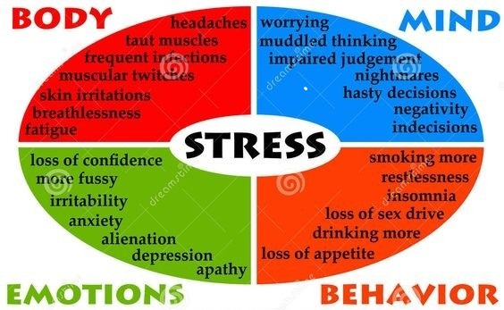

What are sources of stress?
There are four categories of sources of stress:
1. Change of any kind can induce stress because of:
- fear of the new, the unknown
- feelings of personal insecurity
- feelings of vulnerability
- fear of rejection
- need for approval
- lack of tolerance for ambiguity
- fear of conflict
- fear of taking a risk
- fear of developing trust
- fear of inability to cope with changed circumstances
2. Individual personality characteristics that can induce stress include:
- low self-esteem
- feelings of over-responsibility
- fear of loss of control
- fear of failure, error, mistakes
- fear of being judged
- lack of belief in “being good enough”
- chronic striving to be perfect
- chronic guilt
- unresolved grief over a loss or a series of losses
- chronic anger, hostility, or depression
3. Interpersonal issues that can induce stress include:
- a lack of adequate support within the relationship
- a lack of healthy communication within the relationship
- a sense of competitiveness between the parties involved
- threats of rejection or disapproval between people
- an inability to be appropriately assertive
- struggle for power and control in the relationship
- poor intimacy or sexuality within the relationship
- chronic conflict and disagreement with no healthy resolution
- over-dependency of one party on another
- a troubled person who refuses to recognize the need for help
4. System (family, job, school, club, organization) issues that can induce stress include:
- lack of leadership
- lack of sense of direction
- uncooperative atmosphere
- competitive atmosphere
- autocratic leadership
- unclear expectations
- a chronic sense of impending doom
- a lack of teamwork
- confused communications
- developmental disability or chronic ill health of one or more members.
Is all stress bad?
Not all stress is distress:
- a certain amount of stress or pressure is necessary and shows a positive adaptation being made by a person. This is called eustress.
Bad or negative stress is called distress:
- the negative physiological and emotional response when stress is intense and unresolved.
There are three degrees of stress:
- Low: This is distress leading to boredom, fatigue, frustration, or dissatisfaction.
- Optimum: This is eustress leading to creativity, problem solving, progress, change, learning, and energetic satisfaction.
- High: This is distress leading to exhaustion, illness, lack of concentration, excessive mood swings, low self-esteem, and irrational problem solving.
What is a definition of stress?
Stress is defined as a person's response to his environment. Stress is measured in terms of arousal or stimulation. As such, stress must be present for a person to function.
Each person has his own normal (homeostatic) level of arousal at which he functions best. If something unusual in the environment occurs, this level of arousal is affected.
There are three phases of arousal:
- Phase 1 Alarm phase: When an unusual (or stressful) event occurs, the output of energy drops for a short period as the event is registered in the person's mind.
- Phase 2 Adaptation phase: Next, the output of energy increases above the normal level; arousal is heightened as the person seeks to deal with the situation. Adaptation responses available to humans include physically running away, fighting, freezing (self-immobilization), suppression emotion, or learning.
- Phase 3 Exhaustion phase: Finally, the person's available energy is expended and his capacity to function effectively is reduced.

What is the stress/relaxation physical response cycle?

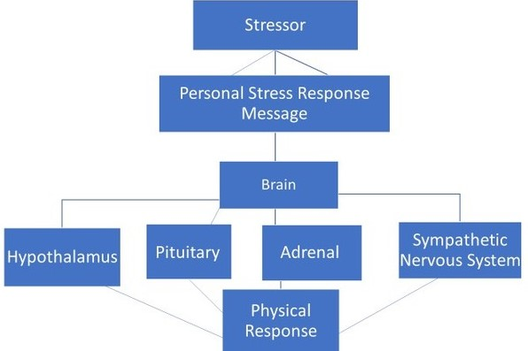
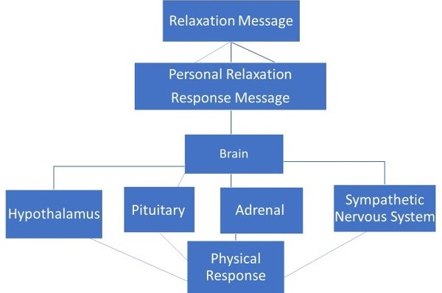

The physical response to stress is as follows:
The signs of this physical response include:
- Increased:
- heart rate
- blood pressure, respiration
- perspiration
- pupil dilation
- muscle tension
What are the results of chronic stress?
In the state of chronic stress
- heart rate
- blood pressure
- respiration are chronically elevated
Common stress-related illnesses include:
- Coronary artery disease
- Peptic ulcer
- Mental illness
A diagram of the stress cycle:
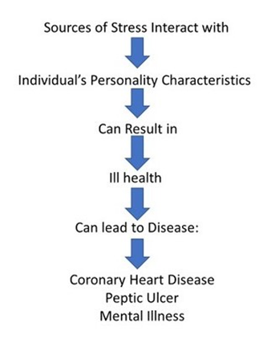

What is personal progressive relaxation?
Progressive relaxation consists of:
1. Learning to relax:
You may have grown to accept a certain high level of stress and anxiety as normal. You may be unfamiliar with what it feels like to be relaxed, calm, and unstressed. With progressive relaxation you learn what it feels like to be relaxed, you learn to increase relaxation to a new level. By doing this you not only improve your physical wellbeing by reducing hypertension, headaches, and other physical complaints, but you improve your mental state by reducing stress, anxiety, irritability, and depression.
2. The physical setting:
Progressive relaxation should take place in a quiet, attractive room. You should be completely supported. There should be no need for exertion to maintain body support. You should wear comfortable, loose-fitting clothing during the sessions.
3. The process:
Lie on the floor or a bed and follow the directions of the relaxation technique as you tense and relax various muscle groups. After the initial tensing of the muscles, release the tension instantly and completely. This is very important in order to get the pendulum effect. The muscles relax beyond the point of their normal relaxed state. You should then feel the important difference between tension and relaxation. You should concentrate on the feeling of relaxation, learn what it is to relax and how to increase it. Continually repeat to yourself, “Know what it feels like to be relaxed, deepen the relaxation, know what it is to be relaxed.”

Do's and don'ts of relaxation:
Do: Make sure you have comfortable, loose clothing and proper back support
Don't: Put yourself in an awkward position or in a position that will make it easy to fall asleep

Do: Allow your mind to quiet down. If tense thoughts enter while you are relaxing, let them pass out of your head.
Don't: Think your way into tension. If you can't clear your mind, take a long, deep breath and let it out slowly.

Do: Stay alert and conscious while you are relaxing. Pay close attention and note any changes in your body (feelings that stand out for you).
Don't: Allow yourself to become groggy and sleepy. If you start falling asleep, open your eyes and sit up. When you are ready, return to relaxation posture.

Do: Go at your own pace and let go of your muscles as your body decides to give up tension.
Don't: Expect yourself to relax all at one. Like any other physical exercise, you must practice letting go step by step.

Do: Give your body messages of appreciation for relaxing as you notice these feelings going through your body.
Don't: Get down on yourself for not relaxing. Your body should be trusted to go at its own pace.

Do: Stay aware of your breathing. Observe how much air you're taking in full breaths at regular rhythms.
Don't: Smoke before, during or after relaxation as it tightens lung tissue and blood vessels. Let your body breathe.

