Pinellas Hope Independent Living Skills Training
Tools for Improving the Quality of Your Life

What is the Quality of Your Managing Your Money
Read each of the following attitudes about money and finances and check as TRUE only those beliefs which you currently hold:
- 1. My having a job will lead to personal security
- 2. My best investment for the future is saving money in the bank
- 3. I conscientiously avoid any kind of debt since debt is bad
- 4. Security is good and must be conscientiously striven for.
- 5. Any type of failure is bad
- 6. I measure my wealth in terms of material possessions
- 7. The government, my employer or someone else is ultimately responsible for my financial well-being
- 8.In order to acquire wealth, I must play dirty and take advantage of others
- 9.I believe that it takes money to make money
- 10.I have not set down any specific written financial goals for myself
- 11.I cannot visualize where I will be financially in fifteen years
- 12.I have no confidence in myself when it comes to believing in my ability to be financially independent in the future
- 13.I believe that it takes a great deal of luck, being at the right place at the right time and knowing the right people to become financially independent
- 14.I like to dream and talk about where I would like me to be financially, but I don't seem to take the action or steps necessary to achieve these goals.
- 15. I look with dread to the day when I will retire and be strapped to a fixed income
To score this inventory, add up the number of “True for me at this time”. Put your score in the appropriate blank. To get tyour score, add up the total the True’s checked.
My Score ___
Score Rating Interpretation
1-2 Excellent
You partner are on your way to becoming financially self-reliant.
3-4 Fair
You are experiencing hurdles to becoming financially self-reliant. You need to read more about the truths of money management to help you jump these hurdles.
5 or more Poor
Your financial efforts are not getting you anywhere. You work hard, sweat a lot, but do not see the long term, down the road rewards for your labors. You need to read more about truths of money management to help you plan your future course of financial stability and security.

Inventory of the State of Your Economy
Do this exercise on your own. It is intended to determine your perception of how you react to financial concerns. Put a numerical rating for each of the following items. Use the following rating scale:
1 = Never 2 = Rarely 3 = Sometimes 4 = Almost Always 5 = Always
- [1] I worry about my debts and being able to meet my financial obligations.
- [2] I make no effort to ensure that I have a nest egg set aside for possible future emergencies.
- [3] I hate income tax time
- [4] I wonder where I will get the money to cover my bills at the end of the month.
- [5] I am not confident that the income I earn is sufficient for my needs.
- [6] I am always looking for a job which will bring in more money.
- [7] I feel like there is not enough income for me to spend time in enjoyable activities such as hobbies, entertainment, sports, etc.
- [8] I am not comfortable with the decision I have made as to job I have as my the primary source of income
- [9] I have concerns about how I handle money.
- [10] If my income from a job is not a necessity for my financial survival, I do not feel I should continue working jobs if I have social security, disability or a pension coming in.
- [11] I want to have a different standard of living than that which I was used to, in my family of origin
- [12] I am concerned that I am living way beyond our means.
- [13] I am bothered by how stingy and tight I am with my own money.
- [14] Having children has (or will) really put a strain on my financial resources.
- [15] I believe that I do not have enough health insurance to cover my needs
- [16] It is important to me to acquire a lot of money and things.
- [17] I find that I am spending more time in my work in order to increase our income.
- [18] I believe that it is best when I pay bills with case not maintain a checking account.
- [19] I are not sure what the "good life" means for me
- [20] I believe that money "buys happiness."
- [21] I strongly believe in the notion that money brings security.
- [22] I find that possessions and things have a way of preoccupying or possessing me.
- [23] I do not like the way I have budgeted my money and planney made financial future.
- [24] I worry that "money concerns" will someday be the ruination of our life.
- [25] I believe that financial concerns are the biggest problem in my life.

My Score: ______ To score this inventory, add up the numerical ratings for each of the 25 items.

Score Ratings Interpretation
25-40 Outstanding Economy
You have an outstanding economy. Perhaps you would like to assist the President and Congress next.
51-65 Good Economy
You have the mind of an accountant. Perhaps H & R Block could use you. But don't be too over confident. Your state of the economy is good at this time.
66-80 Stable Economy
You might be getting into trouble if you don't take some preventative action now. Look at the areas where you need to put some effort and work at it, The state of your economy is stable, but it could flounder in the near future.
81-95 Bleak Economy
You might be or are getting yourself into some financial problems. You might need to seek the assistance of counselor. The state of your personal economy is bleak.
96-125 Troubled Economy
Not only is your economy in trouble, but you may be bankrupt. Get help now from professionals who can assist you to get your books and self in order.

What are your Attitudes about Money?
One of the stickiest problems people have is money. The more you are able to explore this area the better chance you have of avoiding a painful future. Poor money management is said to be a major factor in personal unhappiness. The issue lies not in the amount of money available nor in a person’s ability to manage money, but rather in the lack of personal certainty on ways of handling money. In such cases, people become depressed and decide not to decide.
When this issue raises its ugly head, one of several things can happen:
- You feel down, inadequate, foolish or broken
- You stop trying to manage your money issues
- You can find it hard to decide on a plan and never settle on one plan
The following questions should be filled out individually to assist you deal with handling money. Once you answer these questions see if you have found why you are “no where” in the financial planning arena.
Read the following questions and write your answers as completely and honestly as you can.

1. How much is my income? $____ a year
How much should I make to live securely? $______a year.
2. Do I believe money is to be spent and enjoyed and not hoarded? Yes No
Do I believe extra money should be saved for a rainy day? Yes No
3. Do I want to work on increasing my income? Yes No If yes, why?

4. Do I want to set up a special account for some special purpose? Yes No If yes, for what purpose?

5. Do I plan a budget? Yes No If no, why?

6. Do I stick by a budget if planned? Yes No If no, why?

7. Am I inclined to charge things? Yes No If yes, what are some recent items I have charged?

8. Do I spend money to help myself get out of a low mood? Yes No If yes, what are some recent purchases I have made to help me get out of a low mood?

9. How do I behave when a salesperson is really high-pressuring me?

10. Do I keep my books and pay the bills in a proper manner? Yes No If no, why?

11. How do I feel when I talk about money with others?

12. How does my family background in attitudes towards money, spending and saving habits?

The Fifteen Realities about Personal Finances
Myth | Reality
1. Having a job leads to wealth | Having a good job, working hard and moving up the ladder to more responsibility will not necessarily take you to golden years of retirement, wealth and happiness. The fact is that jobs support our needs and habits (like eating) but it rarely leads to wealth. The answer is not to work harder but to work smarter to become financially stable and self-reliant.
2. Saving money is good. | The discipline of saving money as investment is important, but you cannot expect your savings to carry you to financial independence. Assuming minimal inflation and taxes, any dollar earning less than about 15% per year is a losing venture and at best is the slow liquidation of wealth.
3. Debt is bad and should be avoided. | Yes, any debt which is incurred in the acquisition of material possessions which give you the appearance of wealth should be avoided. However, going into some form of investment debt is essential in order to become, eventually financially self-reliant or independent.
4. Security is good. | Security is often an illusion consider the present state of the Federal Social Security System. The more you love security, the more likely you will avoid risk. If you avoid risk, you also avoid opportunity, because risk is the price you pay for opportunity. Risk is an essential part of progress on the road to financial self-reliance.
5. Failure is bad. | Failure is a part of success. One must develop a positive mindset about failure. One can learn from it and develop ingenuity, flexibility and an  ability to create new ways of achieving goals. In turning failures into success, failure can be the best thing that ever happened to you.
6. Wealth is measured in terms of material possessions. | Wealth is not money. Money and things are just the appearance of wealth. Wealth is a state of mind - an attitude. Using your accumulated experience and knowledge and a positive attitude about your abilities is the road to true wealth and financial independence.
7. The Government, my employer, or someone else is responsible for my financial well-being. | We alone are responsible for our ultimate financial welfare.
8. Acquiring wealth is a dirty win/lose game. | You can take advantage of infinite sources of wealth which can be tapped into without reducing others' chances of becoming wealthy.
9. It takes money to make money | It does take money to make money, .but it does not have to be your own money .Borrowing and investing are means to create personal wealth,
10. Writing down future financial goals is a pipe dream. | A realistic goal that is not written down is a wish or daydream. When you are serious enough to commit your goals to paper and read them regularly, you energize your commitment and creativity.
11. It is silly to visualize a goal or dream. | By using mental imagery for the visualization of your financial goals just before drifting off to sleep or just after waking up in the morning you can influence your subconscious mind. Success in attainment of visualized goals has been proven successful in athletics and dramatically documented by the number of athletes who use mental imagery to win in their respective sports.
12. It is corny to affirm yourself as you pursue your goal of financial self-reliance. | It takes a lot of self-esteem to accomplish great things. To build self-confidence one must practice self-affirmation of one's qualities, abilities and positive attitudes. If you believe in yourself you will project this, and it will build confidence, not only in you, but in your partner's confidence in you to achieve your financial goals.
13. It takes luck to become financially independent. | Rather than luck, it takes a high probability of success to achieve one's financial goals. You must work to increase your probability of success by learning the skills needed and trying harder to use them.
14. Becoming financially self reliant sounds good in theory, but it will never work in reality, | By failing to act you will fail to succeed. You need to leap from theory to practice. It is worse to fail to try than to try and fail. You must get yourself organized, confidence bolstered, and ready to take the risk in order to take action - so do it now!
15 Retirement should be a dreaded event. | By taking steps to become financially self-reliant and by working hard at visualizing and affirming your success, you can achieve the goals which make future retirement a desired goal rather than a dreaded event.

Now you should take the steps necessary to succeed by setting up your long range financial aerobics plan for financial self-reliance.

My Long Range Financial Plan
- My financial goals to be achieved in the next fifteen years are:

- The visual image we will visualize mentally for this goal is:

- The affirmations I will make daily to keep these goals active are:

- My plan of action to achieve these goals is:
Steps to be taken By me By when

- I will be able to evaluate how successfully I have reached my 15 year financial goal by reviewing the following behaviors, accomplishments and achievements which I expect to experience in the next 15 years.
I commit to the above plan.
______________________ ____________________________
My Signature Date
Follow-up Work-Out Plans for Getting My Values on Track
As a result of the exercises, discussions, and efforts in this section on Managing Personal Finances, I have come up with this action plan to continue and follow up the health enhancing which I have just completed.

I. My Financial Needs
The following are needs which I still have to address to fully achieve full health in the financial aspect of my life:
1.
2.
3.
4.
5.

II. Strategic Steps towards Growth in Financial Planning
The following are specific steps I will take to address my needs to improve handling my handling of my finances:
1.
2.
3.
4.
5.

III. Personal Responsibility Taking
The following are the things I will specifically do to ensure that I to grow in dealing with my financial handling:
1.
2.
3.
4.
5.

IV. Evaluation of Action Plan for My Financial Responsibility Taking
I will know I have achieved my goal to grow in the financial area of my life by the following measurable behavioral changes:
1.
2.
3.
4.
5.

I agree to the above plan for financial responsibility taking and I commit to the above plan.

______________________ ____________________________
My Signature Date
Managing Your Time So that You Can Achieve Your Goals in Life
What is time management?
Time management is an endless series of decisions that gradually change the shape of your life. Inappropriate decisions produce frustration, low self-esteem and increased stress. They can result in the following symptoms of poor time management:
- Procrastination; deadlines constantly being missed
- Chronic vacillation between unpleasant alternatives
- Fatigue or listlessness; many hours of unproductive activity
- Rushing from one project to the other; no satisfied feelings of accomplishment
- Insufficient time for rest or personal relationships
- The sense of being overwhelmed by demands and details; doing what you have to do instead of what you want to do most of the time
The methods of time management can be learned by realizing that:
- You can establish priorities that highlight your most important goals, allowing you to base your decisions on what is important to you and what is not.
- You can create time by realistic scheduling and by the elimination of low priority tasks.
- You can learn to make basic decisions.
Take a time inventory - How do you spend your time?
An easy way to find out is to use this Time Inventory Chart. At the end of each day write down the time spent on each of your activities. The total amount of time for all activities should equal the total number of hours you were awake. Keep this time inventory for seven days. At the end of seven days, note the total amount of time spent in each of the categories.

Time Inventory Chart
 | Mon | Tues | Wed | Thur | Fri | Sat | Sun | Total
Sleep
Hours Awake
Work: Office/Home
Commuting/Travel
Eating
Dressing/Personal Hygiene
Family/Personal Work
Education/Self-Improvement
Community & Professional Activities
Leisure

Hours Unaccounted For __________
Set goals for yourself
Using your Time Inventory (which you fille out above), compare your current use of time to your achievement of goals.
First: Imagine yourself as very old and aware that your days are numbered.
- What had you hoped to accomplish in your life?
- What makes you most proud?
- What is your biggest regret?
- Put down anything that comes to mind. Don't think about it or analyze it if something occurs to you, write it down. Use this list for your long-range goals.
Second: make a list of one year goals, those that stand a reasonable chance of being accomplished within the next twelve months. Use this list as your medium range goals.
Third: put down your goals for the coming month, including work priorities, personal growth, recreational activities, etc. Use this list as your short-range goals.
Fourth: You have created three lists of goals: long, medium and short range. Prioritize each list by deciding the top, middle, and low priority items:
- Top priority: those items ranked most essential to you.
- Middle priority: those items that could be put off for awhile, but are still important to you.
- Low priority: those items that could be put off indefinitely with no harm done.
Once you have prioritized your lists, choose four top priority items from each list. You will have twelve top priority items representing your current goals.
Time Management Goal Planner
Lifetime Goals (long range)
1.
2.
3.
4.
One year goals (medium range)
1.
2.
3.
4.
One month goals (short range)
1.
2.
3.
4.
Pick two top priority goals from each of the above categories. Enter them here. These are the goals you will begin to work on now.
1.
2.
3.
4.
5.
6.
These six top priority goals should occupy your time for one month. Next month make a new list. Some goals will remain top priority, others will drop off. The goals will always be accompanied by a list of specific, easy to accomplish steps. Set aside a certain time period each day to work on your top priority goals. Emphasize results rather than activity. Try to accomplish one step toward your goals each day, no matter how small.

Use “to do” lists
If you find it hard to keep focused on top priority items, you will need a daily “to do” list. The “to do” list includes everything you would like to accomplish in one day. Each item is rated top, middle, or low priority. If you find yourself doing a low priority item with some of the top priority items unfinished, you can be almost certain that you are wasting your time.
- Work your way down from the top items. Only when they are completed should you work on the middle priority tasks. Only when everything else is done should you work on the low priority items. You will find that it is often acceptable to ignore the low priority items.
- It can be easy to let top priority goals slip to the back of your mind and say, “Not today. I'll get to it later.” One solution to this tendency is to make signs describing your six top priority goals and post them conspicuously around your house, office, or car. You will be reminded of your priorities often.
- Remember to cross each item off from My Daily Planner as it is accomplished.

How do you overcome Procrastination?
Here are some specific ways to overcome procrastination:
- Know what you want to do, and realize that you will pay later for not acting now.
- Recognize the unpleasantness. Any correct decision is often a little more difficult than an incorrect one, or making no decision at all. Face the prospect of how unpleasant the right decision may be. Examine the greater unpleasantness of putting it off or doing it the easy way. Look squarely at the cost and risks of delay. Use this information to create enthusiasm for getting something done in a time frame that will result in less overall unpleasantness.
- Examine the real payoffs for not deciding or taking the easy way. For example, you avoid being anxious if you procrastinate. You won't call attention to yourself or have to face the possibility of failure.
- Examine the advantages of avoiding whatever changes might follow from making a decision. You might have to face up to the difficult task of revising your self-concept upward. You might have to give up your depression, or the secondary gain of attention that you get from being chronically unhappy.
- Exaggerate your resistant behaviors. Exaggerate and intensify whatever you are doing that is putting off the decision to begin a task. If you are staring at yourself in the bathroom mirror in the morning instead of getting to work, draw it out. Really study all your pores. Go over each quadrant of your face minutely. Keep it up until you are really bored, and getting to work seems much more exciting.
- Take responsibility for each delay. You are the one wasting your own precious time. Make a list of each procrastination or escape activity and note how long it took.
- Decide everything now. Include in the decision when you will set aside all escapes to begin the task.
- Prime yourself with lead-in tasks. Lead yourself into the activity gradually with a small but related task. If you have to mow the lawn, decide to go as far as filling the gas tank on the mower, then wheeling it out to the edge of the lawn.
- Finish things, avoid beginning a new task until you have completed every segment of your current task. The satisfaction of finishing a task is one of the greatest rewards in decision making.
- Don't think about it. Just Do It. (Like Nike says!)

Some solutions for time wasters

Time Waster: Lack of planning
Possible Cause: Failure to see the benefit of planning Solution: Recognize that planning may take time but it saves time and effort in the long run.
Possible Cause: Action oriented Solution: Emphasize results, not activity.
Possible Cause: Success without it Solution: Recognize that success is often in spite of, not because of, methods.

Time Waster: Lack of priorities
Possible Cause: Lack of goals and objectives Solution: Write down goals and objectives. Discuss priorities with coworkers and family members.

Time Waster: Over commitment
Possible Cause: Broad interests Solution: Learn to say no.
Possible Cause: Confusion in priorities Solution: Reassess your goals
Possible Cause: Failure to set priorities Solution: Develop a personal philosophy regarding time. Relate priorities to a schedule of events.

Time Waster: Management by crisis
Possible Cause: Lack of planning Solution: Apply the same solutions as for lack of planning.
Possible Cause: Unrealistic time estimates Solution: Allow more time. Allow for interruptions.
Possible Cause: Problem oriented Solution: Be opportunity oriented
Possible Cause: Reluctance of others to break bad news. Solution: Encourage fast transmission of information as essential for timely corrective action.

Time Waster: Telephone, Cell Phone, Texting, E-mail
Possible Cause: Lack of self-discipline Solution: Screen and group calls & messages. Be brief.
Possible Cause: Desire to be informed and involved. Solution: Stay uninvolved with all but essentials. Manage by exception.

Time Waster: Haste
Possible Cause: Impatience with detail Solution: Take time to get it right. Save the time of doing it over.
Possible Cause: Responding to the urgent Solution: Distinguish between the urgent and the important.
Possible Cause: Lack of planning ahead Solution: Take time to plan. It repays itself many times over.
Possible Cause: Attempting too much in too little time. Solution: Attempt less, delegate much more.

Time Waster: Routine, trivia
Possible Cause: Lack of priorities Solution: Set and concentrate on priority goals. Delegate nonessentials.
Possible Cause: Over surveillance of situations. Solution: Give yourself the the right to do it your way. Look to results, not details or methods.
Possible Cause: Refusal to take responsibility; feeling of greater security dealing with operating detail Solution: Recognize that without taking responsibility, it is impossible to grow. Forget perfectionism.

Time Waster: Visitors
Possible Cause: Enjoyment in socializing Solution: Do it elsewhere. Meet visitors outside living and work setting. Suggest lunch, if necessary or hold stand-up conferences on the spot.
Possible Cause: Inability to say no. Solution: Screen. Say no. Be unavailable. Modify the open-door policy.

Now that you have read about these time wasters, answer the following questions:
- What time wasters prevent you from getting your work done on a typical day?
- Identify activities this week that were ritualistic and relatively ineffective.
- Identify tasks this week that could have been delegated.
- What tasks did you do this week that could have been simplified?
- What single activity or habit wastes most of your time?
Study your answers, and take the steps necessary to eliminate your time wasters.
Some ways to save time in your life
- Write down your ideas. Do not trust your memory, however good it might be!
- Set your priorities first thing in the morning, before any work gets underway.
- Use your high productivity hours for your high priority projects.
- Do not overschedule. Leave two hours of the day free from appointments.
- Tackle time-consuming projects in stages.
- Concentrate on one item at a time.
- When a day's work is overtaxing, get out for lunch. Plan to have lunch with a friend or do something recreational.
- Use your low productivity hour(s) for easy to do projects and casual reading.
- Work on the appointment system as much as possible.
- Carry a 3 x 5 card in your pocket to jot down ideas when you are away from your work setting.
- Carry reading material with you at all times. Use waiting time to read.
- Use travel time to listen to or to dictate material on audio recorders. Utilize a cellphone if possible.
- Set reasonable deadlines for yourself and others.
- Make decisions now whenever possible. If further information is not likely to change the ultimate course of the decision, do not wait.
- Batch items for discussion and talk at scheduled times. Do not make contact every time you have a thought or an item for discussion. Encourage others to do the same.
INTRODUCE EXERCISE INTO YOUR LIFE
Developing a Healthy Exercise Program
- Identify Benefits
- Combat Myths about exercising
- Combat Roadblocks to exercising
- Identify and overcome: Triggers to avoid, ignore, or stop exercising
- Look at what is new in exercise offerings
Benefits of Healthy Exercise
- Compensates for fat accumulation by burning calories
- Provides a "natural high'' by the release of endorphins
- Strengthens the cardiovascular and respiratory systems if aerobic type exercise sustained for at least fifteen minutes on a regular basis.
- Keeps the muscular system supple
- Keeps the circulatory system operating at its best
- Builds bone mass to combat osteoporosis.
Myths About Exercise
1. Exercise makes you tired. Because heart rate and respiration is increased, a person becomes energized, alert, and awake after a period of strenuous exercise.
2. Exercise increases your appetite. The immediate effect of exercise is a decrease in appetite
3. Exercise is boring. Rigorous exercise results in the production of hormones called endorphins which give a feeling of well-being, a "natural high
4. With exercise you can reduce certain spots on your body. Where people lose weight is determined by their hormones. With proper exercise people can increase muscle tone in certain areas and can speed along the general loss of fat, which helps overall appearance but not necessarily in specific areas.
5. You have to have athletic ability to get the most out of an exercise program. A complicated program of sophisticated athletic activities is unnecessary. Simply walking a1/2 hour to hour a day during time when you normally would have been sedentary is enough exercise to provide some balance in your life.
6. A health spa or gym is the best place to exercise. Health spas and gyms can be useful if you need a social atmosphere in which to exercise. However, the type of exercise needed for lifestyle change can be done effectively with no expense.
7. Exercise takes a lot of time and expensive equipment. You need only 30- 45 minutes of consecutive, brisk, full-body movement a day to gain the full benefit of exercise. You can do this in your home with your own equipment (e.g., stationary cycle, rebound trampoline, or rowing machine), or you can do it without equipment by walking, jump roping, etc...
Roadblocks to Exercise
- Not enough time; my schedule is already so full
- Implementing a program of exercise takes exceptional effort and planning
- The health club is too far away. It is not "on my way'' to anywhere
- An exercise program costs a lot of money.
- It is unpleasant to get all sweaty when you exercise
- Exercise can be so boring
- Exercise makes your body sore
Time for Exercise
- Make the exercise session a priority of the day
- schedule a regular, specific time of day for exercise.
- Choose a convenient time.
- Exercise in the morning before breakfast, in the afternoon before lunch, or in the evening after getting home from work, but before dinner.
Place for Exercise
- Choose an exercise easily performed around the house, e.g., treadmill, stationary cycle, rowing machine, jumping rope, rebound trampoline, jumping jacks, walking, running, biking, swimming.
- Perform exercises that can be done in an air-conditioned environment (stationary cycle, rowing machine, or rebound trampoline). Profuse sweating is not necessary for exercise to be worthwhile.
Reduce Costs of Exercise
- Choose an exercise which doesn't involve the purchase of equipment or club memberships, e.g., walking, running, jumping rope, etc.
Keep Exercise Interesting
- Try indoor exercise in front of a TV or while listening to motivational tapes or energizing music.
- Try outdoor exercise in tree-lined or park-like settings with interesting scenery and use a portable radio or tape player
- For either type of exercise, get a partner or group of people to exercise with; make it a social experience that will provide mutual motivation and encouragement
Start out Slow to Protect Your Body from Being Strained
- Slowly phase an exercise program in; help your body adjust to the increased activity
- Use warm-up and cool-down exercises to avoid muscle strain
- Wear the proper clothing and shoes to avoid body strain or injury
Exercise can help you live longer
- Dr. Steven Blair of the Institute of Aerobics Research in Dallas conducted the largest study measuring fitness ever conducted.
- He found that regular exercise will indeed help a person live longer.
- The eight-year study evaluated the fitness and mortality levels of 13,344 men and women.
- Study found that exercise reduces the death rate from all causes, particularly cancer and heart disease.
- Physical fitness was measured by each subject's performance on a standardized treadmill test - a test designed to accurately assess aerobic fitness (the most commonly accepted indicator of cardio-respiratory fitness).
- Based on the test results, the subjects were then grouped by gender into five categories ranging from least to most fit.
- Results of the study, published in the Journal of the American Medical Association, showed that the higher the fitness level the lower the death rate, after the data were adjusted for age differences between the subjects.
- Compared with the most-fit subjects, individuals in the least-fit category had death rates 3.4 and 4.6 times higher for men and women respectively.
- The differences in mortality rates held relatively constant even after adjustments for coronary risk factors, such as smoking and cholesterol level, were considered.
- For both men and women, the largest drop from one fitness category to another was from the least-fit to the next most-fit group.
- Expressed as deaths per 10,000 person-years, the age-adjusted death rates for men and women in the sedentary category fell from 64 and 39.5 to 25.5 and 20.5 respectively in the next most-fit group
- This was a decline of more than 60 percent for men and 48 percent for women.
- Implication are extraordinarily significant, particularly for a sedentary individual. On a major scale, this study documents the fact that a modest amount of exercise can and does go a long way.
- The equivalent of brisk walking 30 minutes a day is all that is required to move from the most sedentary category to the next most fit category.
All About Walking - Types of Walking:
Standing and Intermittent Walking
- Activities such as cooking, gardening or office work
- It provides little cardiovascular benefit but adds to your daily activity level-keeps from being sedentary
- Try to stay on your feet for a total of one hour a day, in addition to your regular exercise
Strolling or Casual Walking (2 mph)
- Activities such as shopping or walking with small children
- It does not provide an adequate workout for your heart and lungs
- But it does get you off the couch and can provide social and emotional benefits
Purposeful or Functional Walking (2-3 mph)
- Gets you where you are going
- Walking the dog around the block
- Walking across complex or campus
- It is not intense enough for an aerobic training effect, but if done long enough it burns calories, helps circulate the blood and clear the cobwebs
- This is not the walk which gives you the benefits you need for a Healthy Lifestyle
Hiking or Distance Walking (2-5 mph)
- Walking for fitness and pleasure
- You can enjoy fresh air and scenery as well as the company of friends and family
- This is not the walk which gives you the benefits you need for a truly Healthy Lifestyle
Brisk Walking, Fitness Walking, or Exercise Walking (3-5 mph) IDEAL
- To achieve health benefits if done often, hard and long enough
- When done properly, numerous health and fitness benefits are derived
- Risk for heart attacks and other degenerative diseases is reduced
- Highly recommended it fits all lifestyles over the ages
Striding or Aerobic Walking (4 mph)
- The length of stride is extended and the arms are pumped or used in an exaggerated manner
- The extra effort of the arms and legs increases the intensity of the workout as well as the calorie burn rate
- Difficult to maintain since it is for weight loss plans but not for a Healthy Lifestyle lifelong program
Intermittent or Interval Walking (2-3 or 3-5 mph)
- Walking done at alternating speeds
- Example, one minute of striding or fast walking is alternated with one minute of regular walking
- This method may add variety to your workout and help you achieve a faster pace when walking at a steady speed
Power Walking or Weighted Walking (3-5 mph)
- With weights on the hands, wrists, trunk or waist
- Weighted workouts increase the intensity of the workout, calorie burn rate and provide upper body toning with the hand or wrist weights
- Risk of increased strain on the joints
Climbing (2-5 mph)
- Climbing: Stairs, Hills, Mountains, Aerobic Climbers, Inclined Treadmills
- Fitness walking done to increase the intensity of the workout
- It is an advanced technique and not recommended for unfit beginners
Treadmill Walking (3-5 mph)
- Done on a treadmill indoors
- On some models, the speed and the degree of incline can be adjusted
- It is great during bad weather or for watching television while walking
- A no excuse model, not dependent on weather conditions and can be used for the recommended brisk Walking, Fitness Walking, or Exercise Walking (3-5 mph)
Race Walking (6-9 mph)
- Competitive walking for conditioned athletes
- It is a form of walking popular with those who are interested in walking for fitness, but not necessarily for competition
- Race walking involves a technique that needs to be learned and practiced
- We are not grooming Race Walkers in this Healthy Lifestyle Training
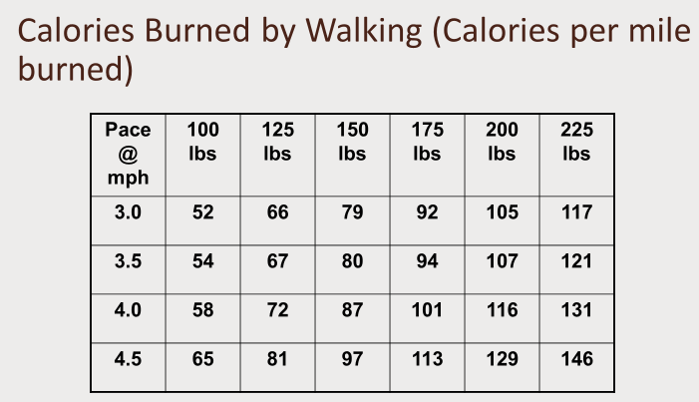
Calories burned by walking
DO NOT FORGET
- You have to subtract the number of calories you naturally are burning by just being alive and awake
- DO NOT count just on burning calories by walking to help you lose and manage your weight
Walking as an exercise workout
- Walking is one of the best fitness activities there is
- It's easy
- It can help you lose and keep off weight
- It's good for your heart
- Risk of injury is virtually nil for the recommended brisk walking
Positives
- Walking is inexpensive and low tech
- All need is sturdy pair of walking shoes
- You can adjust pace, technique & terrain to accommodate your fitness level
- Walking is one of the best exercise for strengthening bones, controlling weight, toning the leg muscles, maintaining good posture & improving positive self-concept
Negatives
- Some people find walking a bore
- It may take you longer to lose weight on a walking program than it would with some other forms of exercise, especially if you don't pick up the pace at least some of the time
Get the most out of your walking workout
- Keep your head up and centered between your shoulders & your shoulders back & down – Watch Your Posture!
- Your chest should be lifted and your abs strong
- Your arms should be bent at 90 degrees.
- Swing them back and forth - not side to side
- Keep your hands loosely cupped
- Power your movements from your hips rather than your thighs but keep your hips loose and natural
- Take short, fast strides that still feel natural rather than awkward
- Keep an even stride. Roll forward on the ball of your foot, push off from your toes and land heel first
- Don't forget to breathe deeply!
- Be consistent & choose specific time to take your walks each day & stick to plan.
- Establish walking as a regular habit
- Work up to 30 to 60 minutes of brisk walking at least three times a week.
- Allow adequate time for warm-up before walk & cool-down period after walk
What you need to make your walking workout work for you
Requirements:
- Gear: Walking shoes, comfortable clothing
- Facilities: Anywhere but you might want to try a track, treadmill or trail
- Time: 30-60 minutes, 3-6 days a week.
Additional Tips to get the most out of your walking workout
Rehydrate
- Always replenish your body with fluids depleted by aerobic activity
- Drink 8-10 oz water for every 20 min of activity
- Water is preferred drink for exercise sessions lasting one hour or less
- For activities exceeding 1 hour, consider sports drinks to replenish lost electrolytes
Clothing
- Choose loose fitting garments that allow your body's heat to evaporate
- Consider the new sport fibers that whisk away moisture, preventing chafing of the skin
- Wear reflective clothing at night
Shoes
- Select a lighter weight walking shoe
- Look for extra shock absorption in heel & ball of the shoe - Shock absorption is crucial to avoid heel pain & burning or tenderness in the ball of the foot
- A low heel slightly beveled in the rear helps accommodate the heel strike & forward roll of the foot.
- Make sure you select a good walking shoe that addresses any special needs for your feet or legs
- If you have chronic problems seek medical advice
- You may need orthotics before engaging in a long-term walking program
Exercise in healthy environments
- If the outdoor temperature is high with excessive humidity (greater than or equal to 75 degrees F with greater than or equal to 60% humidity) exercise inside with air conditioning
- If the weather is below 40 degrees F, dress warmly and in layers
- To avoid air pollution, exercise in the early morning or late afternoon and away from car exhaust
- If you have a respiratory condition, check with your doctor or refrain from exercising during extreme cold & high pollution days unless exercising in a controlled indoor environment
- Protect yourself from lightning & storms
- Avoid unfamiliar or dangerous places
- Walk on sidewalks and safe pathways preferably with a friend
- Always carry identification and obey all traffic laws
Fitness Walking: 5 Minute Warm-up & Cool Down
- Prior to walking do short routine of static stretches (each stretch held for approximately 8-10 seconds) for upper & lower body, e.g. back, calves and shins
- Simple warm-up – 5 min easy striding pace
- The easier pace allows heart rate & blood pressure to climb gradually to your training level
- You should end vigorous walking with leisurely-paced strolling for another two to three minutes, allowing time for your cardiovascular system to adjust to a pre-exercise level
- Recovery heart rate is generally taken two to five minutes after aerobic exercise
- Quicker your heart rate recovers to its pre-exercise level better shape you're in
Walking Stretches
- To reduce risk of injury and soreness, do the following stretches at the beginning and end of your walks
- Hold each of these stretches at the point of tension for 10 seconds
- Then repeat each stretch for the opposite side
Achilles/Calf Stretch
- Keeping both feet pointing forward, bend your front knee and press your back heel into the ground
Hamstring Stretch
- Gently straighten both legs as you lean your body forward
Quadriceps Stretch
- Gently grasp your ankle with the opposite hand, pointing your knee to the ground
Side Stretch
- Keeping your hips steady and knees slightly bent, gently reach overhead to one side
Stretching Flexibility Routine
- Stand on the right leg, bend the left leg so that knee is facing ground & reach behind grabbing left ankle with left hand
- Now slowly use left hand to bring left leg further behind the body, lifting slightly up at the same time Be sure to keep both hips facing forward Use right hand steady self against tree or pole Hold position till feel pleasant stretch through front of left thigh & then repeat on right side
How to get started with Walking for Exercise – Use FIT formula
F=Frequency (How often you should walk)
- You need to exercise at least 3-5 times a week to get the minimal benefits
I=Intensity (How fast you should walk)
- The general rule is to walk at a pace of 3-5 miles an hour
T=Time or (How long you should walk)
- You should walk for a minimum of 30 minutes a day
How to use walking as way of acquiring or maintaining fitness
- Find way to introduce some variety & spice into your walking program
- Once adaptation to certain level of exercise occurs, body is no longer working very hard to accomplish what once may have taken lot of effort
- If body coasts along with no discernible effort, a lot of the benefits you're getting from your exercise may be compromised
- Make walks a kind of interval training
- 30-90 seconds of fast walking alternated with intervals of slower walking
- Alternate fast walking interval with short sprints, step-ups on a park bench, walking lunges
- End workout with some core work for abs and some stretching
- Result-walking=complete fitness program
- Include stretching since pulls, strains & other“runner”problems can happen to walkers
- Warming up is usually done by beginning your walk at slower pace
- Remember muscles respond best to stretching when warm Don't go out on cold day & begin to stretch - Stretches best done after workout or after warm-up
Walking at 10 minute intervals counts
- A recent study conducted at Stanford University took a group of people and divided them into two groups
- Half exercised for 30 consecutive minutes
- Other half exercised in 10 minute intervals - once in the morning, afternoon, & evening
- At the end of the study, both groups increased their fitness levels at the same amount and at the same pace
- So, not having a consecutive half hour is no longer a reason not to get up and get moving!
- If you only have 10 minutes, use it to your advantage
- At the end of the study, both groups increased their fitness levels at the same amount and at the same pace
- So, not having a consecutive half hour is no longer a reason not to get up and get moving!
- If you only have 10 minutes, use it to your advantage
- If after work you are waiting for your bus - Walk!
- Plan walks & schedule in Day Planner
- Recognize how much better you feel when you get back to your work site
- Look at your walk as a welcomed break from work, not as a disruption
- Let co-workers know what you are doing Some will want to join in
- If you are feeling tired and unmotivated, you may need a snack
- Low blood sugar level can make you feel lack luster
- Set short term goals and plan a reward:
- “This week I will walk 5 times or 8 miles or a total of 2 hours”
- After you reach your goals make sure you reward yourself - a new walking t-shirt, tape, shoes, flowers, massage
- Set a long-term goal and shoot for something even bigger -a fully planned vacation

EATING WISELY
THE NEW AMERICAN PLATE
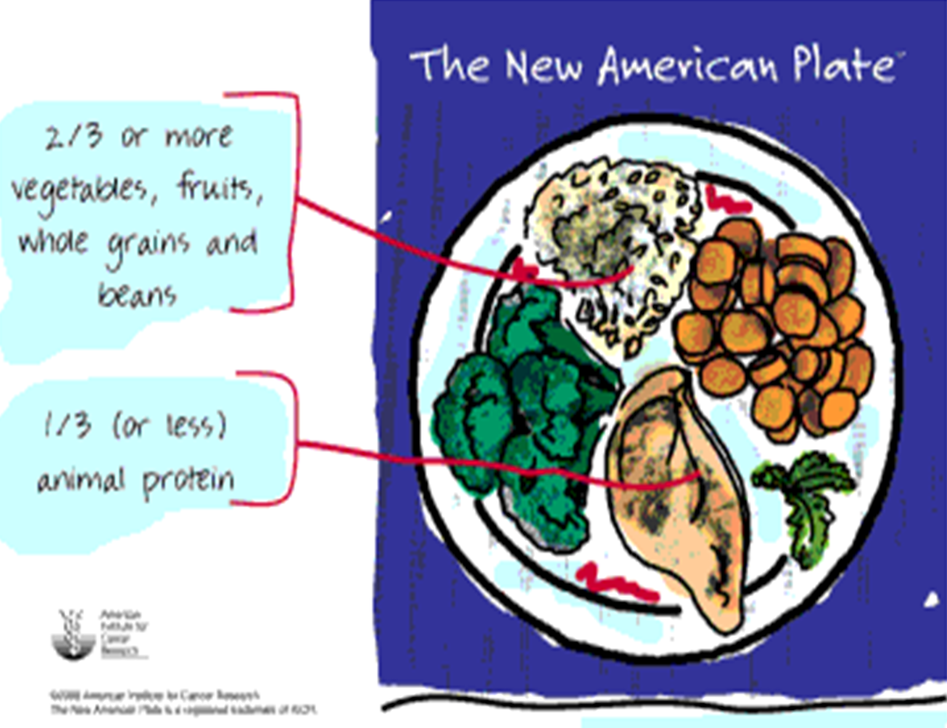
Why the American Institute for Cancer Research was involved:
- Studies show that more than half the adults in this country are overweight
- About one in five are classified as obese and at special health risk
- Problem continues to grow, even though as many as 25% men & 40% women are on a diet at any given time
- It's become apparent that diets don't work
- What's worse, they distract us from the larger issue of overall health
What is the New American Plate?
- New approach to eating for better health
- Emphasizes kinds of foods that can significantly reduce risk for disease
- Shows how to enjoy all foods in sensible portions
- Promotes a healthy weight as just one part of an overall healthy lifestyle
- It's not a short-term "diet" to use for weight loss
American Plate addresses one part of a big puzzle
Large & growing body of research shows
- What we eat
- How we live
- have a lot to do with our risk of developing cancer
- As well as heart disease, adult onset diabetes & many other chronic health problems
The New American Plate Does not Deprive - it satisfies
- Variety of vegetables, fruits, whole grains & beans is at center of new American Plate
- These plant-based foods are
  - Rich in substances that help keep us in good health
  - Protect against many types of cancer
  - Naturally low in calories
- When plant-based foods are on plate, we're able to eat larger, more satisfying meals - all for fewer calories than typical American diet
- Switching to the New American Plate & healthy lifestyle it reflects does not require deprivation
- There is nothing you have to give up
- You will not go hungry
- The New American Plate may not be overflowing, but it is full of great tasting food for better health
On What is New American Plate based on
- From: Food, Nutrition and the Prevention of Cancer: a global perspective, published by the American Institute for Cancer Research
- Report was written by expert scientist panel who reviewed more than 4,500 research studies from around world
- It remains most comprehensive report ever done in the area of diet, nutrition and cancer
- Estimates from the AICR report show that 30-40% of all cancers could be prevented through changing way we eat & exercise
- Eliminating tobacco would raise that figure to 60-70%
- These simple action steps represent best advice science currently offers for lowering your cancer risk
AICR Diet and Health Guidelines for Cancer Prevention
- Choose a diet rich in a variety of plant-based foods.
- Eat plenty of vegetables and fruit.
- Maintain a healthy weight and be physically active.
- Drink alcohol only in moderation, if at all.
- Select foods low in fat and salt.
- Prepare and store food safely.
- And always remember...
Do not use tobacco in any form.
Proportion-What's on New American Plate? - General rule of thumb:
- Plant-based foods like vegetables, fruits, whole grains & beans should cover two-thirds (or more) of plate
- Meat, fish, poultry or low fat dairy should cover one-third (or less) of plate
- Plant-based part of plate should include substantial portions of one or more vegetables or fruits — not just grain products like pasta or whole grain bread.
Plenty of Vegetables and Fruits
- Make sure to eat at least five servings of vegetables & fruits each day
- Research suggests that this could prevent as many as 20% of all cancers
- They provide vitamins, minerals & phytochemicals (natural substances found only in plants) that protect body's cells from damage by cancer-causing agents-stopping cancer before it even starts. A number of phytochemicals may also interfere with cancer cell growth & reproduction
- Reach five servings by including fruits or vegetables at every meal
- Eat a variety of these healthful foods
- Include vegetables that are dark green & leafy
- Vegetables deep orange in color
- Include citrus fruits & other foods high in Vitamin C
- Juice does count-but most should come from solid fruits & vegetables
Other Plant-based Foods
- In addition to fruits and vegetables daily eat at least seven servings of other plant-based foods
- Includes grains (such as whole wheat bread, pasta, oatmeal, barley & brown rice)
- legumes (dried beans and peas, including kidney, garbanzo and black beans, lentils & green peas)
- Make sure to include whole grains in your meal choices each day-higher in fiber & natural phytochemicals than refined grains like white bread & rice
Meat on the Side
- If you eat red meat like beef, pork or lamb, choose lean cuts and limit yourself to no more than a 3 ounce cooked (4 ounce raw) portion per day
- That's about the size of a deck of cards
- Findings from AICR's expert report show that diets high in red meat probably increase the risk of colon cancer
- Research on the impact of poultry, fish and game is not as extensive, so no specific limits have been set
- Just keep portions small enough that you have room to eat an abundance of vegetables, fruits, whole grains & beans
- Reverse the traditional American plate
- Think of meat as a side dish or condiment rather than the main ingredient
- It can be as simple as preparing your favorite, store-bought brown rice or grain mix & topping it with steamed green beans, carrots, yellow squash & an ounce or two of cooked chicken
When is a Vegetable a High-calorie Food?
- When covered in cheese sauce, gravy, regular salad dressing, full-fat sour cream or any other high-fat topping
- Way you cook also makes a difference
- Frying in oil or butter adds a hefty dose of fat and calories to food
How best to cook vegetables?
- Keep your vegetables, fruits, whole grains, beans & lean meats-healthy as well as tasty
- Bake, steam, microwave or stir-fry in a small amount of oil
- Cook with fragrant herbs and spices
- Sprinkle with a few chopped nuts, or a strong-tasting cheese like Parmesan or extra-sharp cheddar
- Choose flavorful and low fat toppings such as marinara sauce, salsa, mustard, reduced-sodium soy sauce & flavored vinegar
- Even a simple squeeze of lemon works wonders.
Plate 1: The Old American Plate
- Heavy on meat, fish or poultry-fully half plate is loaded down with huge (8-10 oz.) steak
- Remainder is filled with a hearty helping of buttery mashed potatoes & peas
- Although meal is home-style favorite, it is high in fat & calories & low in phytochemicals & fiber
Plate 2: The Transition Plate
- Features more moderate (4-6 oz.) serving of meat.
- Large helping of green beans prepared with your favorite herbs
- Addition of a filling whole grain (seasoned brown rice) increased the proportion of nutritious, plant-based foods
- Getting on right track
Plate 3: A Better Plate
- Modest 3 ounce serving of meat (red meat, poultry or fish)
- Two kinds of vegetables help increase the proportion of plant-based foods
- Healthy serving of a tasty whole grain (brown rice, barley, kasha, bulgur, millet) completes the meal
Plate 4: The New American Plate
- A one-dish dinner like stir-fry is just the kind of meal that belongs on the New American Plate
- It's bursting with colorful vegetables, hearty grains & cancer-fighting vitamins, minerals and phytochemicals
- Red meat, poultry or seafood is used as a condiment, adding a bit of flavor & substance to the meal.
- Plates like this one show the delicious possibilities
- New tastes, colors and textures
- Found on the New American Plate
Portion size is an important factor
- Central to New American Plate is recognition that it's not just what we eat that matters, but also how much we eat of each food
- statistics from USDA: average number of calories Americans eat each day has risen from 1,854 to 2,002 over last 20 years
- That significant increase 148 calories per day theoretically works out to an extra 15 pounds every year
Standard Serving Sizes
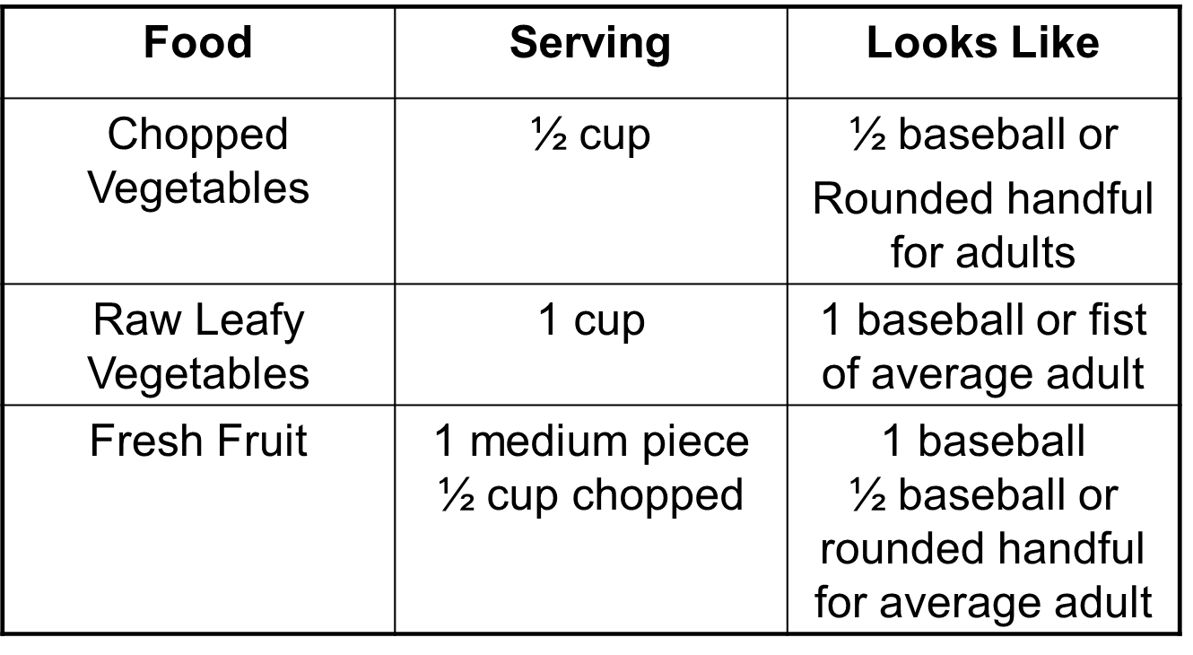

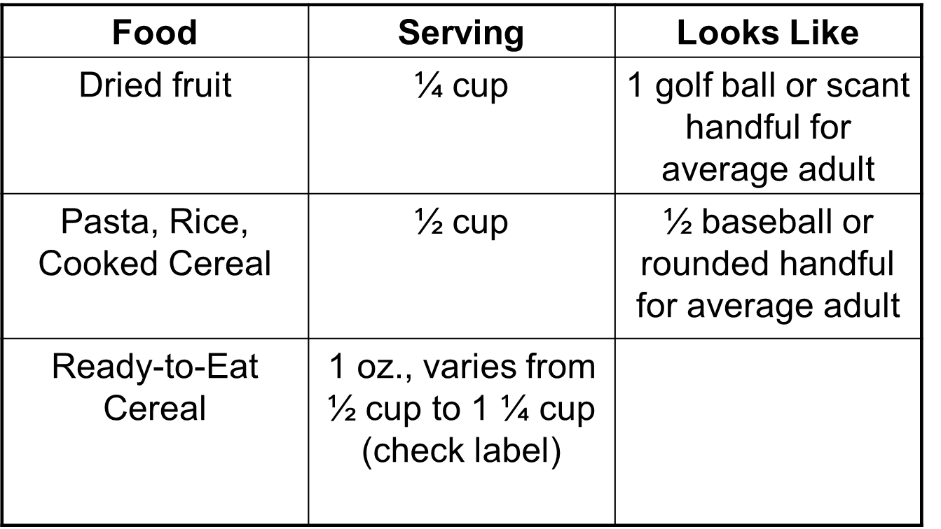

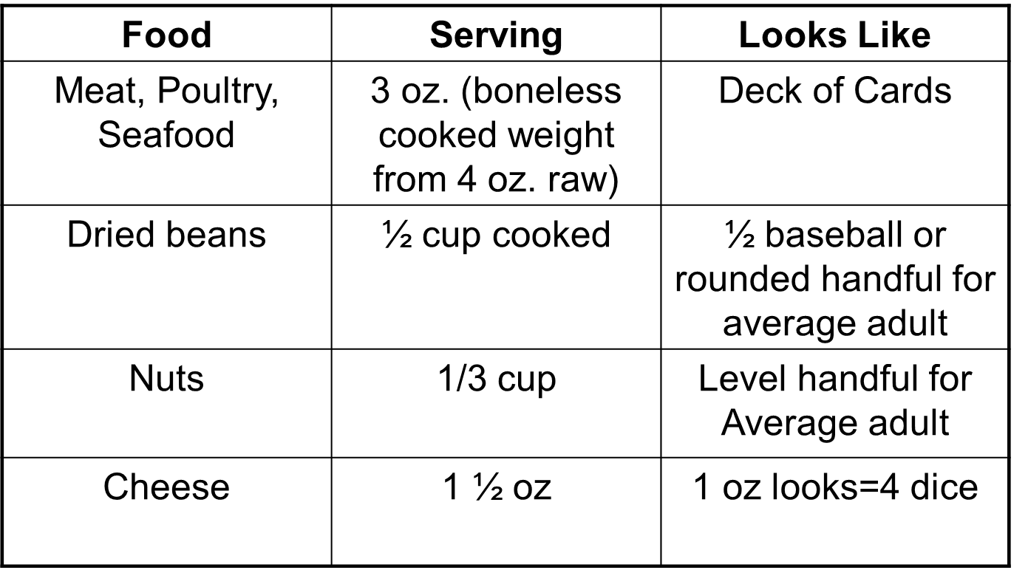
Portion size is an important factor
- Two cups of spaghetti covering dinner plate equals not one, but four grain servings.
- Small bagels found in grocery store freezer aisles equal about two grain servings
- Jumbo bagels commonly served in shops & cafés are closer to four or five
- Full bowl of whole grain cereal you pour yourself in the morning may amount to two or three grain servings — a good head start on what you need for the day
Portions and Weight Loss
- New American Plate features more food & fewer calories than traditional meat-based meal
- It's possible to feel satisfied eating meals with vegetables, fruits, whole grains & beans & work toward healthy weight
- Add some regular physical activity, and you have a safe, effective way to manage your weight for the long-term
Alternatives with New American Plate
Barbecue-Old American  2 hamburgers or hotdogs  ½ cup potato salad  Chips  Brownies  Lunch – Old American  Sandwich with 4 oz. of meat  Snack crackers  Cookies | Barbecue-New American  1 burger (preferably lean meat or veggie)  1 cup marinated vegetable salad  2 melon slices or ½ cup fruit salad  1 brownie  Lunch – New American  Sandwich with 2 oz. of meat, sliced tomato, cucumber and fresh spinach  Piece of fresh fruit  1 cookie if desired
Italian Restaurant-Old American  Veal parmigiana  Pasta  Salad | Italian Restaurant-New American  Large bowl of minestrone soup  ½ portion pasta with marinara sauce  Salad
AICR recommends along with the New American Plate
- One hour a day of brisk physical activity & one hour a week of more vigorous exercise
- That's the recommendation for reducing cancer risk
- Any exercise you do is better than none In working towards this activity level, you will burn more calories, which will help lower your weight

Model Calorie Food Plans - Three Calorie Food Plans
- 1200 Calories – Spartan – for those who are needing a JUMPSTART to motivate themselves
- 1500 Calories – Long Run – for those who are in it for the long run and not needing rapid weight loss at beginning
- 2000 Calories – Gradual – for those who are willing to take gradual steps to implementing lifestyle changes or for those who are going into a maintenance mode in their programs
Calorie Food Plan Allow for:
- Breakfast
- Mid Morning Snack
- Lunch
- Mid Afternoon Snack
- Dinner
- Late Evening Snack
1200 Calorie Food Plan - Spartan
Breakfast - 200 calories
- (2) pieces of 50 calorie bread and 1 piece of fruit
or
- (6) egg whites in Pam and 1 piece fruit
Mid-Morning Snack – 100 calories
- (1) piece fruit or the equivalent in vegetables
or
- (1) 100 calorie yogurt
or
- (1) 100 calorie power bar
Lunch - 300 Calories
- Big Salad and 4 ounces of grilled chicken or shrimp
or
- (2) pieces of 50 calorie bread; 100 calories of Healthy Chicken or Turkey, lettuce, tomato, and Dijon Mustard
or
- Stir-fried vegetables in Pam with chicken or shrimp
or
- (6) egg white omelet in Pam with vegetables and sliced tomato
Mid-Day Snack – 100 calories
- Same as Mid-Morning Snack
Dinner - 400 Calories
- (4) ounces of chicken, fish or shrimp, big salad with fat free dressing and one medium-sized potato
or
- Stir-fried vegetables in Pam with chicken, shrimp or fish
Late night Snack – 100 calories
- Same as Mid-Morning Snack
1500 Calorie Food Plan – Long Run
Breakfast - 200 calories
- (2) pieces of 50 calorie bread and 1 piece of fruit
or
- (6) egg whites in Pam and 1 piece fruit
or
- (1) 100 calorie yogurt and (1) piece of fruit
or
- (1) serving of cereal (one cup) with 1/2 cup of skim milk
or
- (1) serving of Quaker Instant Oatmeal –prepared with water
Mid-Morning Snack – 200 Calories
- (2) piece fruit or (2) cups of vegetables (baby carrots, sliced tomato, etc.)
or
- (1) 100 calorie yogurt plus (1) piece of fruit or one cup of vegetables
or
- (1) 100 calorie Jell-O Fat Free Pudding plus 100 calories of fruit or vegetables
or
- (1/2) cup of fat-free cottage cheese with one serving of fruit.
Lunch - 300 Calories
- Big Salad and 6 ounces of grilled chicken or shrimp Dressing should be balsamic vinegar or small serving fat-free dressing.
or
- (2) pieces of 50 calorie bread; 100 calories of Healthy Chicken or Turkey, lettuce, tomato, and Dijon Mustard
or
- Stir-fried vegetables in Pam with 6 ounces of chicken or shrimp
or
- (6) egg white omelet in Pam with vegetables and sliced tomato
Mid-Day Snack – 100 calories
- Same choices as Mid-Morning Snack but only at 100 calories
Dinner - 500 Calories
- (6) ounces of chicken, fish or shrimp, big salad with fat free dressing and one medium-sized potato
or
- Stir-fried vegetables in Pam with (6) ounces chicken, shrimp or fish and cup of rice
or
- (6) ounces of lean red meat with a big salad and fat-free dressing; if you choose the red meat and medium-sized potato
or
- (1) cup of any kind of pasta with Healthy Choice Marinara Sauce or another fat-free option,a salad with fat-free or balsamic vinegar; add to the pasta some steamed broccoli, carrots, cauliflower, mushrooms, etc
or
- (2) Boca burgers, lettuce, tomato, ketchup or mustard with a salad and a medium-sized baked potato
Late Night Snack – 200 Calories
- Same as Mid-morning snack
2000 Calorie Food Plan – Gradual
Breakfast - 200 calories
- (2) pieces of 50 calorie bread and 1 piece of fruit
or
- (6) egg whites in Pam and 1 piece fruit
or
- (1) 100 calorie yogurt and (1) piece of fruit
or
- (1) serving of cereal (one cup) with 1/2 cup of skim milk
or
- (1) serving of Quaker Instant Oatmeal –prepared with water
Mid-Morning Snack – 200 Calories
- (2) piece fruit or (2) cups of vegetables (baby carrots, sliced tomato, etc.)
or
- (1) 100 calorie yogurt plus (1) piece of fruit or one cup of vegetables
or
- (1) 100 calorie Jell-O Fat Free Pudding plus 100 calories of fruit or vegetables
or
- (1/2) cup of fat-free cottage cheese with one serving of fruit.
Lunch - 400 Calories
- Big Salad and 6 ounces of grilled chicken or shrimp Dressing should be balsamic vinegar or small serving fat-free dressing.
or
- (2) pieces of 50 calorie bread; 100 calories of Healthy Chicken or Turkey, lettuce, tomato, and Dijon Mustard or 200 calories of pretzels or fat-free chips
or
- Stir-fried vegetables in Pam with 6 ounces of chicken or shrimp
or
- (6) egg white omelet in Pam with vegetables and sliced tomato
Mid-Day Snack –200 calories
- Same choices as Mid-Morning Snack
Dinner - 800 Calories
- (6) ounces of chicken, fish or shrimp, big salad with fat free dressing and one large-sized potato
or
- Stir-fried vegetables in Pam with (6) ounces chicken, shrimp or fish and cup of rice
or
- (6) ounces of lean red meat with a big salad and fat-free dressing; if you choose the red meat and large-sized potato
or
- (1) cup of any kind of pasta with Healthy Choice Marinara Sauce or another fat-free option,a salad with fat-free or balsamic vinegar; add to the pasta some steamed broccoli, carrots, cauliflower, mushrooms, etc
or
- (2) Boca burgers, lettuce, tomato, ketchup or mustard with a salad and a medium-sized baked potato
Late Night Snack – 200 Calories
- Same as Mid-morning snack

